INDEX

MODULE REF NO | SUBJECT | PAGE NO
 | Index | 1,2
 | Amendment Record Sheet | 3
 | Contents | 4
9.1 | General | 5-9
9.1.1 | The need to take human factors into account;
9.1.2 | Incidents attributable to human factors/human error;
 | ‘Murphy's’ law.
9.2 | Human Performance and Limitations | 10-24
9.2.1 | Vision;
9.2.2 | Hearing;
9.2.3 | Information processing;
9.2.4 | Attention and perception;
9.2.5 | Memory;
9.2.6 | Claustrophobia and physical access.
9.3 | Social Psychology | 25-36
9.3.1 | Responsibility: individual and group;
9.3.2 | Motivation and de-motivation
9.3.3 | Peer pressure;
9.3.4 | ‘Culture’ issues;
9.3.5 | Team working;
9.3.6 | Management, supervision and leadership
9.4 | Factors Affecting Performance | 37-50
9.4.1 | Fitness/health;
9.4.2 | Stress: domestic and work related;
9.4.3 | Time pressure and deadlines;
9.4.4 | Workload: overload and underload;
9.4.5 | Sleep and fatigue, shiftwork;
9.4.6 | Alcohol, medication, drug abuse
9.5 | Physical Environment | 51-56
9.5.1 | Noise and fumes;
9.5.2 | Illumination;
9.5.3 | Climate and temperature;
9.5.4 | Motion and vibration;
9.5.5 | Working environment.
9.6 | Task | 57-61
9.6.1 | Physical work;
9.6.2 | Repetitive tasks;
9.6.3 | Visual inspection;
9.6.4 | Complex systems.
9.7 | Communication | 62-66
9.7.1 | Within and between teams;
9.7.2 | Work logging and recording;
9.7.3 | Keeping up to date, currency;
9.7.4 | Dissemination of information
9.8 | Human Error | 67-74
9.8.1 | Error models and theories;
9.8.2 | Types of error in maintenance tasks;
9.8.3 | Implications of errors (i.e accidents)
 | Avoiding and managing errors.
9.9 | Hazards in the Workplace | 75-77
9.9.1 | Recognising and avoiding hazards;
9.9.2 | Dealing with emergencies.

AMENDMENT RECORD SHEET

AMENDMENT NO | A MENDMENT CARRIED OUT BY | SIGNATURE | DATE
 | `

CONTENTS

AWN | Airworthiness Notice
BCAR | British Civil Airworthiness Requirements
CAA | Civil Aviation Authority
CAP | Civil Aviation Publication
Cd | candela
CHIRP | Confidential Human Factors Incident Reporting Programme
CRM | Crew Resource Management
dB | decibels
FAA | Federal Aviation Administration
fL | footLambert
FOD | Foreign Object Damage
FODCOM | Flight Operations Department Communication
HFAMI | Human Factors in Aviation Maintenance and Inspection
HFCAG | Human Factors Combined Action Group
HFRG | Human Factors in Reliability Group
HSE | Health and Safety Executive
Hz | Hertz
IATA | International Air Transport Association
ICAO | International Civil Aviation Organisation
IMIS | Integrated Maintenance Information System
JAR | Joint Aviation Requirement
LAE | Licensed Aircraft Engineer
lm | lumen
lux | lumens/m²
MEDA | Maintenance Engineering Decision Aid
MM | Maintenance Manual
MORS | Mandatory Occurrence Report Scheme
MRM | Maintenance Resource Management
NIHL | Noise Induced Hearing Loss
NDI | Non-Destructive Inspection
NDT | Non-Destructive Testing
NTSB | National Transportation Safety Board
OJT | On-the-job Training
REM | Rapid Eye Movement
SHEL Model | Software, Hardware, Environment, LivewareSMM Shift Maintenance Manager
SMS | Safety Management System
TWA | Time Weighted Average
VWF | Vibratory - Induced White Finger

Chapter 9.1 INTRODUCTION

1 IMPORTANCE OF HUMAN FACTORS
The greatest impact in aircraft safety in the future will not come from improving the technology. Rather it will be from educating the employee to recognize and prevent human error. A review of accident related data indicates that approximately 75–80 percent of all aviation accidents are the result of human error. Of those accidents, about 12 percent are maintenance related. Although pilot/co-pilot errors tend to have immediate and highly visible effects, maintenance errors tend to be more latent and less obvious. However, they can be just as lethal.
DEFINITIONS OF HUMAN FACTORS
Human factors are concerned with optimizing performance … including reducing errors so that the highest level of safety is achieved and maintained.
—Ron LoFaro, PhD
FAA
Human factors is the study of how people interact with their environments.
—FAA-H-8083-25,
Pilot’s Handbook of Aeronautical Knowledge, dated 2003

Human factors are those elements that affect our behaviour and performance, especially those that may cause us to make errors.

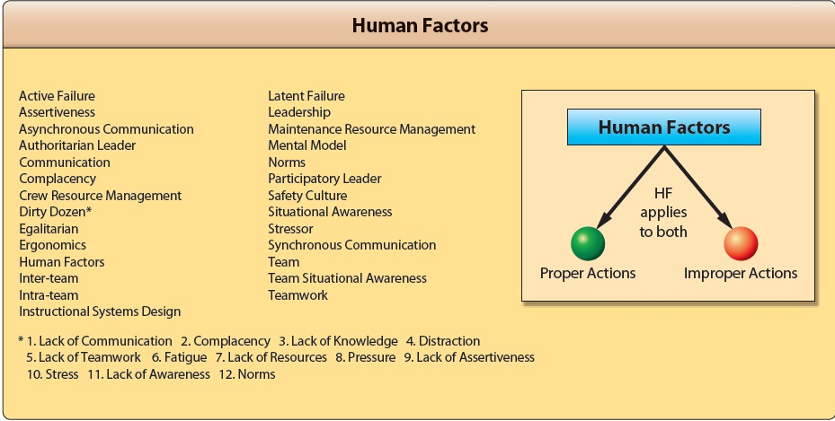

Thus, human factors include such attributes as:

- human physiology;

- Psychology (including perception, cognition, memory, social interaction, error, etc.);

- work place design;

- environmental conditions;

- human-machine interface;

- Anthropometrics (the scientific study of measurements of the human body).

THE SHEL MODEL

It can be helpful to use a model to aid in the understanding of human factors, or as a framework around which human factors issues can be structured. A model which is often used is the SHEL model, a name derived from the initial letters of its components:

- Software (e.g. maintenance procedures, maintenance manuals, checklist layout, etc.);

- Hardware (e.g. tools, test equipment, the physical structure of aircraft, design of flight decks, positioning and operating sense of controls and instruments, etc.);

- Environment (e.g. physical environment such as conditions in the hangar, conditions on the line, etc. and work environment such as work patterns, management structures, public perception of the industry, etc.);

- Liveware (i.e. the person or people at the centre of the model, including maintenance engineers, supervisors, planners, managers, etc.
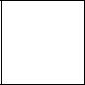

H


S L E

L

Figure 1 SHEL Model.

Human factors concentrates on the interfaces between the human (the ‘L’ in the centre box) and the other elements of the SHEL model (see Figure 1), and - from a safety viewpoint - where these elements can be deficient, e.g.:

- misinterpretation of procedures, badly written manuals, poorly designed checklists, untested or difficult to use computer software

- not enough tools, inappropriate equipment, poor aircraft design for maintainability

- uncomfortable workplace, inadequate hangar space, extreme temperatures, excessive noise, poor lighting

- relationships with other people, shortage of manpower, lack of supervision, lack of support from managers

- Incidents and Accidents Attributable To Human Factors / Human Error

In 1940, it was calculated that approximately 70% of all aircraft accidents were attributable to man’s performance, that is to say human error. When the International Air Transport Association (IATA) reviewed the situation 35 years later, they found that there had been no reduction in the human error component of accident statistics (Figure 2).


OTHER

CAUSES

HUMAN FAILURE

Flight Crew, ATC,

Maintenance, Aircraft
Design, etc.

Figure 2 The dominant role played by human performance in civil aircraft accidents

A study was carried out in 1986, in the USA by Sears, looking at significant accident causes in 93 aircraft accidents. These were as follows:

Causes/ major contributory factors | % of accidents in
 | which this was a factor
• Pilot deviated from basic operational procedures | 33
• Inadequate cross-check by second crew member | 26
• Design faults | 13
• Maintenance and inspection deficiencies | 12
• Absence of approach guidance | 10

• Captain ignored crew inputs |  | 10
• Air traffic control failures or errors |  | 9
• Improper crew response during abnormal conditions |  | 9
• Insufficient or incorrect weather information |  | 8
• | Runways hazards | 7
• Air traffic control/crew communication deficiencies |  | 6
• | Improper decision to land | 6
2.6 EXAMPLES OF INCIDENTS AND ACCIDENTS

There have been several ‘high profile’ incidents and accidents which have involved maintenance human factors problems. The Human Factors in Aviation Maintenance and Inspection (HFAMI) Some of the major incidents and accidents are summarised below. These are:

- Accident to Boeing 737, (Aloha flight 243), Maui, Hawaii, April 28 1988;

- Accident to BAC One-Eleven, G-BJRT (British Airways flight 5390), over Didcot, Oxfordshire on 10 June 1990;

- Incident involving Airbus A320, G-KMAM at London Gatwick Airport, on 26 August 1993;

- Incident involving Boeing 737, G-OBMM near Daventry, on 23 February 1995.

job was signed off as complete.

2.6.2 In all three of these UK incidents, the engineers involved were considered by their companies to be well qualified, competent and reliable employees. All of the incidents were characterised by the following:

- There were staff shortages;

- Time pressures existed;

- All the errors occurred at night;

- Shift or task handovers were involved;

- They all involved supervisors doing long hands-on tasks;

- There was an element of a “can-do” attitude;

- Interruptions occurred;

- There was some failure to use approved data or company procedures;

- Manuals were confusing;

- There was inadequate pre-planning, equipment or spares.

Incidents and Accidents - A Breakdown in Human Factors

In all of the examples above, the accident or incident was preventable and could have been avoided if any one of a number of things had been done differently. In some cases, a number of individuals were involved and the outcome could have been modified if any one of them had reacted or queried a particular action. In each situation however, the individuals failed to recognise or react to signs of potential hazards, did not react as expected of them, or allowed themselves to be diverted from giving their attention to the task in hand, leaving themselves open to the likelihood of committing an error.

2.7.2z As with many incidents and accidents, all the examples above involved a series of human factors problems which formed an error chain (see Figure 3). If any one of the links in this ‘chain’ had been broken by building in measures which may have prevented a problem at one or more of these stages, these incidents may have been prevented.

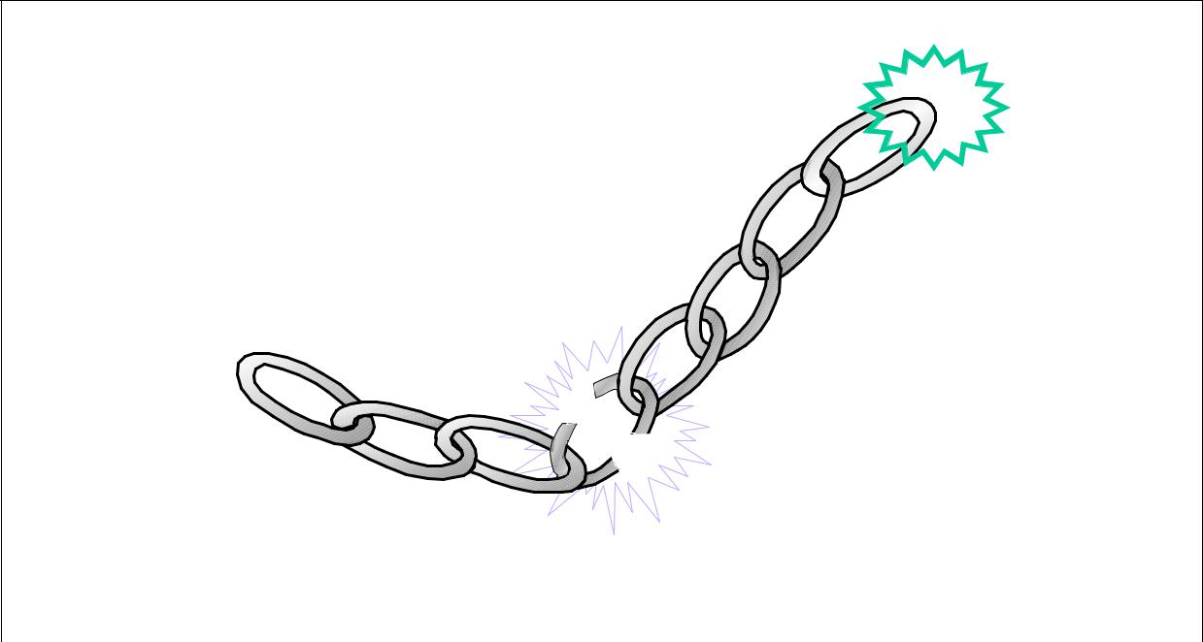
Accident

Crew

Management

Maintenance

If we can break just one link of the chain, the accident does not happen

Figure 3 The Error Chain.

Further chapters in this document aim to help the aircraft maintenance engineer to identify where the vulnerable areas might be within the maintenance ‘link’, how to identify them, and to provide an introduction to those human factors practices and principles which should prevent the error chain reaching a catastrophic conclusion.
3 MURPHY’S LAW

There is a tendency among human beings towards complacency. The belief that an accident will never happen to “me” or to “my Company” can be a major problem when attempting to convince individuals or organisations of the need to look at human factors issues, recognise risks and to implement improvements, rather than merely to pay ‘lip-service’ to human factors.

“Murphy’s Law” can be regarded as the notion: “If something can go wrong, it will.”

3.2 If everyone could be persuaded to acknowledge Murphy’s Law, this might help overcome the “it will never happen to me” belief that many people hold.

CHAPTER 9.2 HUMAN PERFORMANCE AND LIMITATIONS

The intention of this chapter is to provide an overview of those key physical and mental human performance characteristics which are likely to affect an aircraft maintenance engineer in his working environment, such as his vision, hearing, information processing, attention and perception, memory, judgement and decision making.

Human Performance as Part of the Maintenance Engineering System

Just as certain mechanical components used in aircraft maintenance engineering have limitations, engineers themselves have certain capabilities and limitations that must be considered when looking at the maintenance engineering ‘system’. For instance, rivets used to attach aluminium skin to a fuselage can withstand forces that act to pull them apart. It is clear that that these rivets will eventually fail if enough force is applied to them. While the precise range of human capabilities and limitations might not be as well-defined as the performance range of mechanical or electrical components, the same principles apply in that human performance is likely to degrade and eventually ‘fail’ under certain conditions (e.g. stress).

Mechanical components in aircraft can, on occasion, suffer catastrophic failures. Man, can also fail to function properly in certain situations. Physically, humans become fatigued, are affected by the cold, can break bones in workplace accidents, etc. Mentally, humans can make errors, have limited perceptual powers, can exhibit poor judgement due to lack of skills and knowledge, etc. In addition, unlike mechanical components, human performance is also affected by social and emotional factors. Therefore failure by aircraft maintenance engineers can also be to the detriment of aircraft safety.

The aircraft engineer is the central part of the aircraft maintenance system. It is therefore very useful to have an understanding of how various parts of his body and mental processes function and how performance limitations can influence his effectiveness at work.

VISION
The Basic Function of the Eye

In order to understand vision, it is useful first to know a little about the anatomy of the eye (see Figure 4). The basic structure of the eye is similar to a simple camera with an aperture (the iris), a lens, and a light sensitive surface (the retina). Light enters the eye through the cornea, then passes through the iris and the lens and falls on the retina. Here the light stimulates the light-sensitive cells on the retina (rods and cones) and these pass small electrical impulses by way of the optic nerve to the visual cortex in the brain. Here, the electrical impulses are interpreted and an image is perceived.

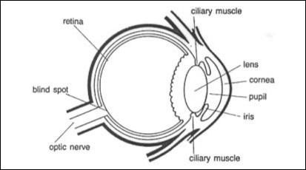

Figure 4 The human eye

The Cornea

The cornea is a clear ‘window’ at the very front of the eye. The cornea acts as a fixed focusing device. The focusing is achieved by the shape of the cornea bending the incoming light rays. The cornea is responsible for between 70% and 80% of the total focusing ability (refraction) of the eye.

The Iris and Pupil

The iris (the coloured part of the eye) controls the amount of light that is allowed to enter the eye. It does this by varying the size of the pupil (the dark area in the centre of the iris). The size of the pupil can be changed very rapidly to cater for changing light levels.

2.4 THE LENS

After passing through the pupil, the light passes through the lens. Its shape is changed by the muscles (cillary muscles) surrounding it which results in the final focusing adjustment to place a sharp image onto the retina. The change of shape of the lens is called accommodation. In order to focus clearly on a near object, the lens is thickened. To focus on a distant point, the lens is flattened. The degree of accommodation can be affected by factors such as fatigue or the ageing process.

When a person is tired accommodation is reduced, resulting in less sharp vision (sharpness of vision is known as visual acuity).

2.5 THE RETINA

2.5.1 The retina is located on the rear wall of the eyeball. It is made up of a complex layer of nerve cells connected to the optic nerve. Two types of light sensitive cells are found in the retina - rods and cones. The central area of the retina is known as the fovea and the receptors in this area are all cones. It is here that the visual image is typically focused. Moving outwards, the cones become less dense and are progressively replaced by rods, so that in the periphery of the retina, there are only rods.

Cones function in good light and are capable of detecting fine detail and are colour sensitive. This means the human eye can distinguish about 1000 different shades of colour.

Rods cannot detect colour. They are poor at distinguishing fine detail, but good at detecting movement in the edge of the visual field (peripheral vision). They are much more sensitive at lower light levels. As light decreases, the sensing task is passed from the cones to the rods. This means in poor light levels we see only in black and white and shades of grey.

2.5.2 At the point at which the optic nerve joins the back of the eye, a ‘blind spot’ occurs. This is not evident when viewing things with both eyes (binocular vision), since it is not possible for the image of an object to fall on the blind spots of both eyes at the same time. Even when viewing with one eye (monocular vision), the constant rapid movement of the eye (saccades) means that the image will not fall on the blind spot all the time. It is only when viewing a stimulus that appears very fleetingly (e.g. a light flashing), that the blind spot may result in something not being seen. In maintenance engineering, tasks such as close visual inspection or crack detection should not cause such problems, as the eye or eyes move across and around the area of interest (visual scanning).

2.6 FACTORS AFFECTING CLARITY OF SIGHT

2.6.1 The eye is very sensitive in the right conditions (e.g. clear air, good light, etc.). In fact, the eye has approximately 1.2 million nerve cells leading from the retinas to the area of the brain responsible for vision, while there are only about 50,000 from the inner ears - making the eye about 24 times more sensitive than the ear.

2.6.2 Before considering factors that can influence and limit the performance of the eye, it is necessary to describe visual acuity.

Visual acuity is the ability of the eye to discriminate sharp detail at varying distances.

2.6.3 An individual with an acuity of 20/20 vision should be able to see at 20 feet that which the so-called ‘normal’ person is capable of seeing at this range. It may be expressed in metres as 6/6 vision. The figures 20/40 mean that the observer can read at 20 feet what a ‘normal’ person can read at 40 feet.

2.6.4 Various factors can affect and limit the visual acuity of the eye. These include:

- Physical factors such as:

  - physical imperfections in one or both eyes (short sightedness, long sightedness),

  - age.

- The influence of ingested foreign substances such as:

  - drugs,

  - medication,

  - alcohol,

  - cigarettes.

- Environmental factors such as:

  - amount of light available,

  - clarity of the air (e.g. dust, mist, rain, etc.).

- Factors associated with object being viewed such as:

  - size and contours of the object,

  - contrast of the object with its surroundings,

  - relative motion of the object,

  - distance of the object from the viewer,

  - the angle of the object from the viewer.

2.6.5 Each of these factors will now be examined in some detail.

2.7 PHYSICAL FACTORS

2.7.1 Long sight - known as Hypermetropia - is caused by a shorter than normal eyeball which means that the image is formed behind the retina (Figure 5). If the cornea and the lens cannot use their combined focusing ability to compensate for this, blurred vision will result when looking at close objects.
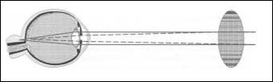

Figure 5 A convex lens will overcome long sightedness by bending light inwards before it reaches the cornea.

2.7.2 Short sight - known as Myopia - is where the eyeball is longer than normal, causing the image to be formed in front of the retina (Figure 6). If the accommodation of the lens cannot counteract this then distant objects are blurred.

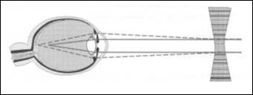

Figure 6 A concave lens will overcome short sightedness by bending light outwards before it reaches the cornea.

2.7.3 Other visual problems include:

- cataracts - clouding of the lens usually associated with ageing;

- astigmatism - a misshapen cornea causing objects to appear irregularly shaped;

- glaucoma - a build up in pressure of the fluid within the eye which can cause damage to the optic nerve and even blindness;

- migraine - severe headaches that can cause visual disturbances.

2.7.4 Finally as a person grows older, the lens becomes less flexible meaning that it is unable to accommodate sufficiently. This is known as presbyopia and is a form of long sightedness. Consequently, after the age of 40, spectacles may be required for near vision, especially in poor light conditions. Fatigue can also temporarily affect accommodation, causing blurred vision for close work.

2.8 FOREIGN SUBSTANCES

Vision can be adversely affected by the use of certain drugs and medications, alcohol, and smoking cigarettes. With smoking, carbon monoxide which builds up in the bloodstream allows less oxygen to be carried in the blood to the eyes. This is known as hypoxia and can impair rapidly the sensitivity of the rods. Alcohol can have similar effects, even hours after the last drink.

2.9 ENVIRONMENTAL FACTORS

2.9.1 Vision can be improved by increasing the lighting level, but only up to a point, as the law of diminishing returns operates. Also, increased illumination could result in increased glare. Older people are more affected by the glare of reflected light than younger people. Moving from an extremely bright environment to a dimmer one has the effect of vision being severely reduced until the eyes get used to less light being available. This is because the eyes have become light adapted. If an engineer works in a very dark environment for a long time, his eyes gradually become dark adapted allowing better visual acuity. This can take about 7 minutes for the cones and 30 minutes for the rods. As a consequence, moving between a bright hanger (or the inside of an aircraft) to a dark apron area at night can mean that the maintenance engineer must wait for his eyes to adjust (adapt). In low light conditions, it is easier to focus if you look slightly to one side of an object. This allows the image to fall outside the fovea and onto the part of the retina which has many rods.

2.9.2 Any airborne particles such as dust, rain or mist can interfere with the transmission of light through the air, distorting what is seen. This can be even worse when spectacles are worn, as they are susceptible to getting dirty, wet, misted up or scratched. Engineers who wear contact lenses (especially hard or gas-permeable types) should take into account the advice from their optician associated with the maximum wear time - usually 8 to 12 hours - and consider the effects which extended wear may have on the eyes, such as drying out and irritation. This is particularly important if they are working in an environment which is excessively dry or dusty, as airborne particles may also affect contact lens wear. Goggles should be worn where necessary.

2.10 THE NATURE OF THE OBJECT BEING VIEWED

Many factors associated with the object being viewed can also influence vision. We use information from the objects we are looking at to help distinguish what we are seeing. These are known as visual cues. Visual cues often refer to the comparison of objects of known size to unknown objects. An example of this is that we associate small objects with being further away. Similarly, if an object does not stand out well from its background (i.e. it has poor contrast with its surroundings), it is harder to distinguish its edges and hence its shape. Movement and relative motion of an object, as well as distance and angle of the object from the viewer, can all increase visual demands.

2.11 COLOUR VISION

2.11.1 Although not directly affecting visual acuity, inability to see particular colours can be a problem for the aircraft maintenance engineer. Amongst other things, good colour vision for maintenance engineers is important for:

- Recognising components;

- Distinguishing between wires;

- Using various diagnostic tools;

- Recognising various lights on the airfield (e.g. warning lights).

2.11.2 Colour defective vision is usually hereditary, although may also occur as a temporary condition after a serious illness.

Colour-defective vision (normally referred to incorrectly as colour blindness) affects about 8% of men but only 0.5% of women. The most common type is difficulty in distinguishing between red and green. More rarely, it is possible to confuse blues and yellows.

2.11.3 There are degrees of colour defective vision, some people suffering more than others. Individuals may be able to distinguish between red and green in a well-lit situation but not in low light conditions. Colour defective people typically see the colours they have problems with as shades of neutral grey.

2.11.4 Ageing also causes changes in colour vision. This is a result of progressive yellowing of the lens, resulting in a reduction in colour discrimination in the blue-yellow range. Colour defective vision and its implications can be a complex area and care should be taken not to stop an engineer from performing certain tasks merely because he suffers from some degree of colour deficient vision. It may be that the type and degree of colour deficiency is not relevant in their particular job. However, if absolutely accurate colour discrimination is critical for a job, it is important that appropriate testing and screening be put in place.

2.12 VISION AND THE AIRCRAFT MAINTENANCE ENGINEER

2.12.1 It is important for an engineer, particularly one who is involved in inspection tasks, to have adequate vision to meet the task requirements. As discussed previously, age and problems developing in the eye itself can gradually affect vision. Without regular vision testing, aircraft maintenance engineers may not notice that their vision is deteriorating.

2.12.2 In the UK, the CAA have produced guidance¹ which states:

“A reasonable standard of eyesight is needed for any aircraft engineer to perform his duties to an acceptable degree. Many maintenance tasks require a combination of both distance and near vision. In particular, such consideration must be made where there is a need for the close visual inspection of structures or work related to small or miniature components. The use of glasses or contact lenses to correct any vision problems is perfectly acceptable and indeed they must be worn as prescribed. Frequent checks should be made to ensure the continued adequacy of any glasses or contact lenses. In addition, colour discrimination may be necessary for an individual to drive in areas where aircraft manoeuvre or where colour coding is used, e.g. in aircraft wiring. Organisations should identify any specific eyesight requirement and put in place suitable procedures to address these issues.”

2.12.3 Often, airline companies or airports will set the eyesight standards for reasons other than aircraft maintenance safety, e.g. for insurance purposes, or for driving on the airfield.

2.12.4 Ultimately, what is important is for the individual to recognise when his vision is adversely affected, either temporarily or permanently, and to consider carefully the possible consequences should they continue to work if the task requires good vision.

- HEARING

3.1 THE BASIC FUNCTION OF THE EAR

3.1.1 The ear performs two quite different functions. It is used to detect sounds by receiving vibrations in the air, and secondly, it is responsible for balance and sensing acceleration. Of these two, the hearing aspect is more pertinent to the maintenance engineer, and thus it is necessary to have a basic appreciation of how the ear works.

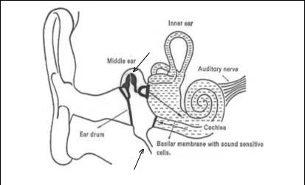

Ossicles

Outer ear

Eustachian Tube

Figure 7 The human ear

3.2 OUTER EAR

The outer part of the ear directs sounds down the auditory canal, and on to the eardrum. The sound waves will cause the eardrum to vibrate.

3.3 MIDDLE EAR

Beyond the eardrum is the middle ear which transmits vibrations from the eardrum by way of three small bones known as the ossicles, to the fluid of the inner ear. The middle ear also contains two muscles which help to protect the ear from sounds above 80 dB by means of the acoustic or aural reflex, reducing the noise level by up to 20 dB. However, this protection can only be provided for a maximum of about 15 minutes, and does not provide protection against sudden impulse noise such as gunfire. It does explain why a person is temporarily ‘deafened’ for a few seconds after a sudden loud noise. The middle ear is usually filled with air which is refreshed by way of the eustachian tube which connects this part of the ear with the back of the nose and mouth. However, this tube can allow mucus to travel to the middle ear which can build up, interfering with normal hearing.

3.4 INNER EAR

Unlike the middle ear, the inner ear is filled with fluid. The last of the ossicles in the middle ear is connected to the cochlea. This contains a fine membrane (the basilar membrane) covered in hair-like cells which are sensitive to movement in the fluid. Any vibrations they detect cause neural impulses to be transmitted to the brain via the auditory nerve.

The amount of vibration detected in the cochlea depends on the volume and pitch of the original sound.

3.5 PERFORMANCE AND LIMITATIONS OF THE EAR

The audible frequency range that a young person can hear is typically between 20 and 20,000 cycles per second (or Hertz), with greatest sensitivity at about 3000 Hz.

3.5.2 Volume (or intensity) of sound is measured in decibels (dB). Table 1 shows intensity levels for various sounds and activities.

Table 1 | Typical sound levels for various activities
Activity |  | Approximate Intensity level
Activity |  | (Decibels)
Rustling of leaves / Whisper |  | 20
Conversation at 2m |  | 50
Typewriter at 1m |  | 65
Car at 15m |  | 70
Lorry at 15m |  | 75
Power Mower at 2m |  | 90
Propellor aircraft at 300m |  | 100
Jet aircraft at 300m |  | 110
Standing near a propellor aircraft |  | 120
Threshold of pain |  | 140
Immediate hearing damage results |  | 150

3.6 IMPACT OF NOISE ON PERFORMANCE

3.6.1 Noise can have various negative effects in the workplace. It can:

- be annoying (e.g. sudden sounds, constant loud sound, etc.);

- interfere with verbal communication between individuals in the workplace;

- cause accidents by masking warning signals or messages;

- be fatiguing and affect concentration, decision making, etc.;

- damage workers’ hearing (either temporarily or permanently).

3.6.2 Intermittent and sudden noise are generally considered to be more disruptive than continuous noise at the same level. In addition, high frequency noise generally has a more adverse affect on performance than lower frequency. Noise tends to increase errors and variability, rather than directly affect work rate. This subject is discussed further in Chapter 5.

3.7 HEARING IMPAIRMENT

3.7.1 Hearing loss can result from exposure to even relatively short duration noise. The degree of impairment is influenced mainly by the intensity of the noise. Such damage is known as Noise Induced Hearing Loss (NIHL). The hearing loss can be temporary

- lasting from a few seconds to a few days - or permanent. Temporary hearing loss may be caused by relatively short exposure to very loud sound, as the hair-like cells on the basilar membrane take time to ‘recover’. With additional exposure, the amount or recovery gradually decreases and hearing loss becomes permanent. Thus, regular exposure to high levels of noise over a long period may permanently damage the hair-like cells in the cochlea, leading to irreversible hearing impairment.

3.7.2 The UK ‘Noise at Work’ regulations¹ (1989) impose requirements upon employers.
They stipulate three levels of noise at which an employer must act:

- 85 decibels (if normal speech cannot be heard clearly at 2 metres), employer must;

  - assess the risk to employees’ hearing,

  - tell the employees about the risks and what precautions are proposed,

  - provide their employees with personal ear protectors and explain their use.

- 90 decibels (if normal speech cannot be heard clearly at 1 metre) employer must;

  - do all that is possible to reduce exposure to the noise by means other than by providing hearing protection,

  - mark zones where noise reaches the second level and provide recognised signs to restrict entry.

- 140 decibels (noise causes pain).

3.7.3 The combination of duration and intensity of noise can be described as noise dose. Exposure to any sound over 80 dB constitutes a noise dose, and can be measured over the day as an 8 hour Time Weighted Average sound level (TWA).

For example, a person subjected to 95 decibels for 3.5 hours, then 105 decibels for 0.5 hours, then 85 decibels for 4 hours, results in a TWA of 93.5 which exceeds the recommended maximum TWA of 90 decibels.

3.7.4 Permanent hearing loss may occur if the TWA is above the recommended maximum.

It is normally accepted that a TWA noise level exceeding 85 dB for 8 hours is hazardous and potentially damaging to the inner ear. Exposure to noise in excess of 115 decibels without ear protection, even for a short duration, is not recommended.

3.8 HEARING PROTECTION

3.8.1 Hearing protection is available, to a certain extent, by using ear plugs or ear defenders.

Noise levels can be reduced (attenuated) by up to 20 decibels using ear plugs and 40 decibels using ear muffs. However, using ear protection will tend to adversely interfere with verbal communication. Despite this, it must be used consistently and as instructed to be effective.

3.9 PRESBYCUSIS

Hearing deteriorates naturally as one grows older. This is known as presbycusis. This affects ability to hear high pitch sounds first, and may occur gradually from the 30’s onwards. When this natural decline is exacerbated by Noise Induced Hearing Loss, it can obviously occur rather sooner.

3.10 HEARING AND THE AIRCRAFT MAINTENANCE ENGINEER

3.10.1 The UK CAA¹ makes the following recommendations regarding hearing:

“The ability to hear an average conversational voice in a quiet room at a distance of 2 metres (6 feet) from the examiner is recommended as a routine test. Failure of this test would require an audiogram to be carried out to provide an objective assessment. If necessary, a hearing aid may be worn but consideration should be given to the practicalities of wearing the aid during routine tasks demanded of the individual.”

3.10.2 It is very important that the aircraft maintenance engineer understands the limited ability of the ears to protect themselves from damage due to excessive noise. Even though engineers should be given appropriate hearing protection and trained in its use, it is up to individuals to ensure that they actually put this to good use. It is a misconception that the ears get used to constant noise: if this noise is too loud, it will damage the ears gradually and insidiously. Noise in the workplace is discussed further in Chapter 5.

- INFORMATION PROCESSING

The previous sections have described the basic functions and limitations of two of the senses used by aircraft maintenance engineers in the course of their work. This section examines the way the information gathered by the senses is processed by the brain. The limitations of the human information processing system are also considered.

Information processing is the process of receiving information through the senses, analysing it and making it meaningful.

4.1 AN INFORMATION PROCESSING MODEL

Information processing can be represented as a model. This captures the main elements of the process, from receipt of information via the senses, to outputs such as decision making and actions. One such model is shown in Figure 8.

Smells

Sounds

Sights

Sensations

Tastes

Short Term

Memory

Motor

Programmes

S T I M U L I
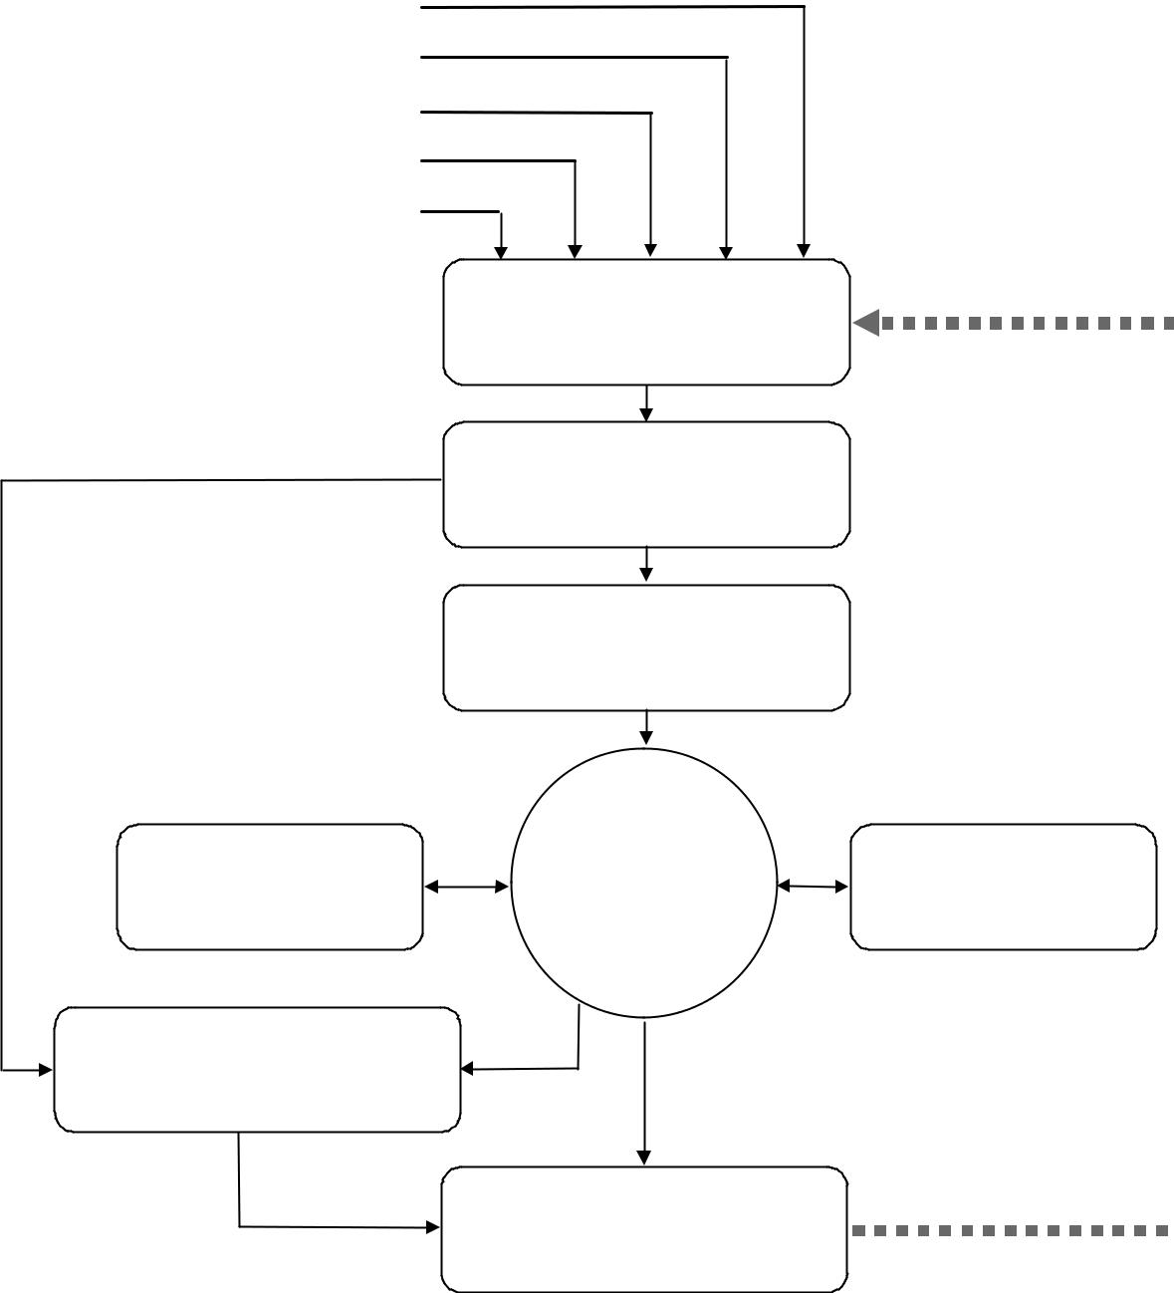

Receptors

and

Sensory Stores

Attention

Mechanism

Perception

CENTRAL

DECISION

MAKER

Actions

Long Term

Memory

F E E D B A C K


Figure 8 A functional model of human information processing

4.2 SENSORY RECEPTORS AND SENSORY STORES

Physical stimuli are received via the sensory receptors (eyes, ears, etc.) and stored for a very brief period of time in sensory stores (sensory memory). Visual information is stored for up to half a second in iconic memory and sounds are stored for slightly longer (up to 2 seconds) in echoic memory. This enables us to remember a sentence as a sentence, rather than merely as an unconnected string of isolated words, or a film as a film, rather than as a series of disjointed images.

4.3 ATTENTION AND PERCEPTION

4.3.1 Having detected information, our mental resources are concentrated on specific elements - this is attention.

Attention can be thought of as the concentration of mental effort on sensory or mental events.

Source: Solso, 1995

4.3.2 Although attention can move very quickly from one item to another, it can only deal with one item at a time. Attention can take the form of:

- selective attention,

- divided attention,

- focused attention

- sustained attention.

4.3.3 Selective attention occurs when a person is monitoring several sources of input, with greater attention being given to one or more sources which appear more important. A person can be consciously attending to one source whilst still sampling other sources in the background. Psychologists refer to this as the ‘cocktail party effect’ whereby you can be engrossed in a conversation with one person but your attention is temporarily diverted if you overhear your name being mentioned at the other side of the room, even though you were not aware of listening in to other people’s conversations. Distraction is the negative side of selective attention.

4.3.4 Divided attention is common in most work situations, where people are required to do more than one thing at the same time. Usually, one task suffers at the expense of the other, more so if they are similar in nature. This type of situation is also sometimes referred to as time sharing.

4.3.5 Focused attention is merely the skill of focussing one’s attention upon a single source and avoiding distraction.

4.3.6 Sustained attention as its name implies, refers to the ability to maintain attention and remain alert over long periods of time, often on one task. Most of the research has been carried out in connection with monitoring radar displays, but there is also associated research which has concentrated upon inspection tasks.²

4.3.7 Attention is influenced by arousal level and stress. This can improve attention or damage it depending on the circumstances. This is covered in more detail in Chapter 4, Sections 2, 3 and 4.
4.3.8 Perception involves the organisation and interpretation of sensory data in order to make it meaningful, discarding non-relevant data, i.e. transforming data into information. Perception is a highly sophisticated mechanism and requires existing knowledge and experience to know what data to keep and what to discard, and how to associate the data in a meaningful manner.

Perception can be defined as the process of assembling sensations into a useable mental representation of the world. Perception creates faces, melodies, works of art, illusions, etc. out of the raw material of sensation.

Examples of the perceptual process:

- the image formed on the retina is inverted and two dimensional, yet we see the world the right way up and in three dimensions;

- if the head is turned, the eyes detect a constantly changing pattern of images, yet we perceive things around us to have a set location, rather than move chaotically.

4.4 DECISION MAKING

4.4.1 Having recognized coherent information from the stimuli reaching our senses, a course of action has to be decided upon. In other words decision making occurs.

Decision making is the generation of alternative courses of action based on available information, knowledge, prior experience, expectation, context, goals, etc. and selecting one preferred option. It is also described as thinking, problem solving and judgement.

4.4.2 This may range from deciding to do nothing, to deciding to act immediately in a very specific manner. A fire alarm bell, for instance, may trigger a well-trained sequence of actions without further thought (i.e. evacuate); alternatively, an unfamiliar siren may require further information to be gathered before an appropriate course of action can be initiated.

4.5 MEMORY

4.5.1 Memory is critical to our ability to act consistently and to learn new things. Without memory, we could not capture a ‘stream’ of information reaching our senses, or draw on past experience and apply this knowledge when making decisions.

Memory can be considered to be the storage and retention of information, experiences and knowledge, as well as the ability to retrieve this information.

4.5.2 Memory depends on three processes:

- registration - the input of information into memory;

- storage - the retention of information;

- retrieval - the recovery of stored information.

4.5.3 It is possible to distinguish between three forms of memory:

- ultra short-term memory (or sensory storage);

- short term memory (often referred to as working memory)

- long term memory.

4.5.4 Ultra short-term memory has already been described when examining the role of sensory stores. It has a duration of up to 2 seconds (depending on the sense) and is used as a buffer, giving us time to attend to sensory input.

4.5.5 Short term memory receives a proportion of the information received into sensory stores, and allows us to store information long enough to use it (hence the idea of ‘working memory’). It can store only a relatively small amount of information at one time, i.e. 5 to 9 (often referred to as 7 ±2) items of information, for a short duration, typically 10 to 20 seconds. As the following example shows, capacity of short term memory can be enhanced by splitting information in to ‘chunks’ (a group of related items).
The duration of short term memory can be extended through rehearsal (mental repetition of the information) or encoding the information in some meaningful manner (e.g. associating it with something as in the example above).

The capacity of long-term memory appears to be unlimited. It is used to store information that is not currently being used, including:

- knowledge of the physical world and objects within it and how these behave;

- personal experiences;

- beliefs about people, social norms, values, etc.;

- motor programmes, problem solving skills and plans for achieving various activities;

- abilities, such as language comprehension.

Information in long-term memory can be divided into two types: (i) semantic and (ii) episodic. Semantic memory refers to our store of general, factual knowledge about the world, such as concepts, rules, one’s own language, etc. It is information that is not tied to where and when the knowledge was originally acquired. Episodic memory refers to memory of specific events, such as our past experiences (including people, events and objects). We can usually place these things within a certain context. It is believed that episodic memory is heavily influenced by a person’s expectations of what should have happened, thus two people’s recollection of the same event can differ.

Motor Programmes

If a task is performed often enough, it may eventually become automatic and the required skills and actions are stored in long term memory. These are known as motor programmes and are ingrained routines that have been established through practice. The use of a motor programme reduces the load on the central decision maker. An often quoted example is that of driving a car: at first, each individual action such as gear changing is demanding, but eventually the separate actions are combined into a motor programme and can be performed with little or no awareness. These motor programmes allow us to carry out simultaneous activities, such as having a conversation whilst driving.

Situation Awareness

Although not shown explicitly in Figure 8, the process of attention, perception and judgment should result in awareness of the current situation.

Situation awareness is the synthesis of an accurate and up-to-date 'mental model' of one's environment and state, and the ability to use this to make predictions of possible future states.

Situation awareness has traditionally been used in the context of the flight deck to describe the pilot’s awareness of what is going on around him, e.g. where he is geographically, his orientation in space, what mode the aircraft is in, etc. In the maintenance engineering context, it refers to¹:

  - the perception of important elements, e.g. seeing loose bolts or missing parts, hearing information passed verbally;

  - the comprehension of their meaning, e.g. why is it like this? Is this how it should be?
- the projection of their status into the future, e.g. future effects on safety, schedule, airworthiness.

An example is an engineer seeing (or perceiving) blue streaks on the fuselage. His comprehension may be that the lavatory fill cap could be missing or the drainline leaking. If his situation awareness is good, he may appreciate that such a leak could allow blue water to freeze, leading to airframe or engine damage.

As with decision making, feedback improves situation awareness by informing us of the accuracy of our mental models and their predictive power. The ability to project system status backward, to determine what events may have led to an observed system state, is also very important in aircraft maintenance engineering, as it allows effective fault finding and diagnostic behavior.

Situation awareness for the aircraft maintenance engineer can be summarised as:

- the status of the system the engineer is working on;

- the relationship between the reported defect and the intended rectification;

- the possible effect on this work on other systems;

- the effect of this work on that being done by others and the effect of their work on this work.

This suggests that in aircraft maintenance engineering, the entire team needs to have situation awareness - not just of what they are doing individually, but of their colleagues’ activities as well.

Information Processing Limitations

The basic elements of human information processing have now been explored. It is important to appreciate that these elements have limitations. As a consequence, the aircraft engineer, like other skilled professionals, requires support such as reference to written material (e.g. manuals).

Attention and Perception

A proportion of ‘sensed’ data may be lost without being ‘perceived’. An example with which most people are familiar is that of failing to perceive something which someone has said to you, when you are concentrating on something else, even though the words would have been received at the ear without any problem. The other side of the coin is the ability of the information processing system to perceive something (such as a picture, sentence, concept, etc.) even though some of the data may be missing. The danger, however, is that people can fill in the gaps with information from their own store of knowledge or experience, and this may lead to the wrong conclusion being drawn.

Once we have formed a mental model of a situation, we often seek information which will confirm this model and, not consciously, reject information which suggests that this model is incorrect.

There are many well-known visual ‘illusions’ which illustrate the limits of human perception. Figure 9 shows how the perceptual system can be misled into believing that one line is longer than the other, even though a ruler will confirm that they are exactly the same.



Figure 9 The Muller-Lyer Illusion

Expectation can also affect our memory of events. The study outlined above was extended such that subjects were asked, a week later, whether they recalled seeing glass on the road after the collision. (There was no glass). The group who had been told that they would see a crash, recalled seeing glass; the other group recalled seeing no glass.

Decision Making, Memory, and Motor Programmes

- Attention and perception shortcomings can clearly impinge on decision making. Perceiving something incorrectly may mean that an incorrect decision is made, resulting in an inappropriate action. Figure 8 also shows the dependence on memory to make decisions. It was explained earlier that sensory and short-term memory have limited capacity, both in terms of capacity and duration. It is also important to bear in mind that human memory is fallible, so that information:

  - may not be stored;

  - may be stored incorrectly;

  - may be difficult to retrieve.

All these may be referred to as forgetting, which occurs when information is unavailable (not stored in the first place) or inaccessible (cannot be retrieved). Information in short-term memory is particularly susceptible to interference, an example of which would be trying to remember a part number whilst trying to recall a telephone number.

It is generally better to use manuals and temporary aides-memoires rather than to rely upon memory, even in circumstances where the information to be remembered or recalled is relatively simple. For instance, an aircraft maintenance engineer may think that he will remember a torque setting without writing it down, but between consulting the manual and walking to the aircraft (possibly stopping to talk to someone on the way), he may forget the setting or confuse it (possibly with a different torque setting appropriate to a similar task with which he is more familiar). Additionally, if unsure of the accuracy of memorised information, an aircraft maintenance engineer should seek to check it, even if this means going elsewhere to do so. Noting something down temporarily can avoid the risk of forgetting or confusing information. However, the use of a personal note book to capture such information on a permanent basis can be dangerous, as the information in it may become out-of-date.

- CLAUSTROPHOBIA, PHYSICAL ACCESS AND FEAR OF HEIGHTS

Although not peculiar to aircraft maintenance engineering, working in restricted space and at heights is a feature of this trade. Problems associated with physical access are not uncommon. Maintenance engineers and technicians often have to access, and work in, very small spaces (e.g. in fuel tanks), cramped conditions (such as beneath flight instrument panels, around rudder pedals), elevated locations (on cherry-pickers or staging), sometimes in uncomfortable climatic or environmental conditions (heat, cold, wind, rain, noise). This can be aggravated by aspects such as poor lighting or having to wear breathing apparatus. The physical environments associated with these problems are examined further in Chapter 5.

5.1 Physical Access and Claustrophobia

5.1.1 There are many circumstances where people may experience various levels of physical or psychological discomfort when in an enclosed or small space, which is generally considered to be quite normal. When this discomfort becomes extreme, it is known as claustrophobia.

Claustrophobia can be defined as abnormal fear of being in an enclosed space.

5.1.2 It is quite possible that susceptibility to claustrophobia is not apparent at the start of employment. It may come about for the first time because of an incident when working within a confined space, e.g. panic if unable to extricate oneself from a fuel tank. If an engineer suffers an attack of claustrophobia, they should make their colleagues and supervisors aware so that if tasks likely to generate claustrophobia cannot be avoided, at least colleagues may be able to assist in extricating the engineer from the confined space quickly, and sympathetically. Engineers should work in a team and assist one another if necessary, making allowances for the fact that people come in all shapes and sizes and that it may be easier for one person to access a space, than another. However, this should not be used as an excuse for an engineer who has put on weight, to excuse himself from jobs which he would previously have been able to do with greater ease!

5.2 FEAR OF HEIGHTS

5.2.1 Working at significant heights can also be a problem for some aircraft maintenance engineers, especially when doing ‘crown’ inspections (top of fuselage, etc.). Some engineers may be quite at ease in situations like these whereas others may be so uncomfortable that they are far more concerned about the height, and holding on to the access equipment, than they are about the job in hand. In such situations, it is very important that appropriate use is made of harnesses and safety ropes. These will not necessarily remove the fear of heights, but will certainly help to reassure the engineer and allow him to concentrate on the task in hand. The FAA’s hfskyway website provides practical guidance to access equipment when working at height. Ultimately, if an engineer finds working high up brings on phobic symptoms (such as severe anxiety and panic), they should avoid such situations for safety’s sake. However, as with claustrophobia, support from team members can be helpful.

Chapter 9.3 SOCIAL PSYCHOLOGY

- RESPONSIBILITY: INDIVIDUAL AND GROUP

2.1 Being an aircraft maintenance engineer is a responsible job. Clearly, the engineer plays a part in the safe and efficient passage of the travelling public when they use aircraft.

If someone is considered responsible, they are liable to be called to account as being in charge or control of, or answerable for something.

2.2 Within aircraft maintenance, responsibility should be spread across all those who play a part in the activity. This ranges from the accountable manager who formulates policy, through management that set procedures, to supervisors, teams of engineers and individuals within those teams. Flight crew also play a part as they are responsible for carrying out preflight checks and walkarounds and highlighting aircraft faults to maintenance personnel.

2.3 WORKING AS AN INDIVIDUAL OR AS A GROUP

2.3.1 Traditionally, in the maintenance engineering environment, responsibility has been considered in terms of the individual rather than the group or team. This is historical, and has much to do with the manner in which engineers are licensed and the way in which work is certified. This has both advantages and disadvantages. The main advantage to individual responsibility is that an engineer understands clearly that one or more tasks have been assigned to him and it is his job to do them (it can also be a strong incentive to an engineer to do the work correctly knowing that he will be the one held responsible if something goes wrong). The main disadvantage of any emphasis upon personal responsibility, is that this may overlook the importance of working together as a cohesive team or group to achieve goals.

2.4 INDIVIDUAL RESPONSIBILITY

2.4.1 All aircraft maintenance engineers are skilled individuals having undertaken considerable training. They work in a highly professional environment in the UK and generally have considerable pride in their work and its contribution to air safety.

2.4.2 All individuals, regardless of their role, grade or qualifications should work in a responsible manner. This includes not only Licensed Aircraft Engineers (LAEs), but non-licensed staff. Airworthiness Notice No. 3 details the certification responsibilities of LAEs. This document states that “The certifying engineer shall be responsible for ensuring that work is performed and recorded in a satisfactory manner

2.5 GROUP OR TEAM RESPONSIBILITY

2.5.1 Group responsibility has its advantages and disadvantages. The advantages are that each member of the group ought to feel responsible for the output of that group, not just their own output as an individual, and ought to work towards ensuring that the whole ‘product’ is safe. This may involve cross-checking others’ work (even when not strictly required), politely challenging others if you think that something is not quite right, etc.

2.5.2 The disadvantage of group responsibility is that it can potentially act against safety, with responsibility being devolved to such an extent that no-one feels personally responsible for safety (referred to as diffusion of responsibility). Here, an individual, on his own, may take action but, once placed within a group situation, he may not act if none of the other group members do so, each member of the group or team assuming that ‘someone else will do it’. This is expanded upon further in the section on peer pressure later in this chapter (4).

Social psychologists have carried out experiments whereby a situation was contrived in which someone was apparently in distress, and noted who came to help. If a person was on their own, they were far more likely to help than if they were in a pair or group. In the group situation, each person felt that it was not solely his responsibility to act and assumed that someone else would do so.

2.5.3 Other recognised phenomena associated with group or team working and responsibility for decisions and actions which aircraft maintenance engineers should be aware of are:

2.5.4 Intergroup conflict in which situations evolve where a small group may act cohesively as a team, but rivalries may arise between this team and others (e.g. between engineers and planners, between shifts, between teams at different sites, etc.). This may have implications in terms of responsibility, with teams failing to share responsibility between them. This is particularly pertinent to change of responsibility at shift handovers, where members of the outgoing shift may feel no ‘moral’ responsibility for waiting for the incoming shift members to arrive and giving a verbal handover in support of the written information on the workcards or task sheets, whereas they might feel such responsibility when handing over tasks to others within their own shift.

Group polarisation is the tendency for groups to make decisions that are more extreme than the individual members’ initial positions. At times, group polarisation results in more cautious decisions. Alternatively, in other situations, a group may arrive at a course of action that is riskier than that which any individual member might pursue. This is known as risky shift. Another example of group polarisation is groupthink in which the desire of the group to reach unanimous agreement overrides any individual impulse to adopt proper, rational (and responsible) decision-making procedures.

Social loafing has been coined to reflect the tendency for some individuals to work less hard on a task when they believe others are working on it. In other words, they consider that their own efforts will be pooled with that of other group members and not seen in isolation.

Further Reading:

- CAA (1999) CAP455: Airworthiness Notices. AWN3. UK Civil Aviation Authority.

- Scoble, R. (1993) Aircraft Maintenance Production And Inspection: Team Work +

Empowerment + Process Simplification = Quality. In: Proceedings of the Eighth Meeting on Human Factors Issues in Aircraft Maintenance and Inspection. Available from http://hfskyway.faa.gov

- Gross, R. (1996) Psychology: The Science of Mind and Behaviour (3rd edition).

London: Hodder & Stoughton - Chapter 20 ‘Social Influence’.

- MOTIVATION AND DE-MOTIVATION

3.1 Motivated behaviour is goal-directed, purposeful behaviour, and no human behaviour occurs without some kind of motivation underpinning it. In aircraft maintenance, engineers are trained to carry out the tasks within their remit. However, it is largely their motivation which determines what they actually do in any given situation. Thus, “motivation reflects the difference between what a person can do and what he will
do”¹.

Motivation can be thought of as a basic human drive that arouses, directs and sustains all human behaviour. Generally we say a person is motivated if he is taking action to achieve something.

3.2 Motivation is usually considered to be a positive rather than a negative force in that it stimulates one to achieve various things. However just because someone is motivated, this does not mean to say that they are doing the right thing. Many
criminals are highly motivated for instance. Motivation is difficult to measure and predict. We are all motivated by different things, for example, an artist might strive over many months to complete a painting that he may never sell, whereas a businessman may forfeit all family life in pursuit of financial success.

3.4 MASLOW’S HIERARCHY OF NEEDS

3.4.1 Possibly one of the most well known theories which attempts to describe human motivation is Maslow’s hierarchy of needs. Maslow considered that humans are driven by two different sets of motivational forces:

- those that ensure survival by satisfying basic physical and psychological needs;

- those that help us to realise our full potential in life known as self-actualisation needs (fulfilling ambitions, etc.).

3.4.2 Figure 13 shows the hypothetical hierarchical nature of the needs we are motivated to satisfy. The theory is that the needs lower down the hierarchy are more primitive or basic and must be satisfied before we can be motivated by the higher needs. For instance, you will probably find it harder to concentrate on the information in this document if you are very hungry (as the lower level physiological need to eat predominates over the higher level cognitive need to gain knowledge). There are always exceptions to this, such as the mountain climber who risks his life in the name of adventure. The higher up the hierarchy one goes, the more difficult it becomes to achieve the need. High level needs are often long-term goals that have to be accomplished in a series of steps.

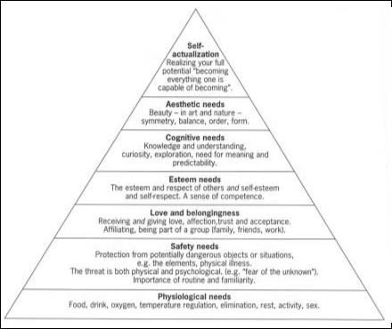

Figure 13 Maslow’s hierarchy of needs. Source: Maslow, 1954¹

3.4.3 An aircraft maintenance engineer will fulfil lower level needs by earning money to buy food, pay for a home and support a family. They may well be motivated by middle level needs in their work context (e.g. social groups at work, gaining status and recognition). It is noteworthy that for shift workers, tiredness may be a more powerful motivator than a higher order need (such as personal satisfaction to get the job done in time or accurately).

An interesting experiment on motivation was carried out in 1924 at the Hawthorne Works of the Western Electric Company in Chicago. Here, the management altered various factors such as rest periods, lighting levels, working hours, etc. and each time they did so, performance improved, even when the apparent improvements were taken away! This suggested that it was not the improvements themselves which were causing the increased production rates, but rather the fact that the staff felt that management were taking notice of them and were concerned for their welfare. This phenomenon is known as the Hawthorne effect.

3.5 DE-MOTIVATION

3.5.1 Highly motivated people tend to show the following characteristics:

- high performance and results being consistently achieved;

- the energy, enthusiasm and determination to succeed;

- unstinting co-operation in overcoming problems;

- willingness to accept responsibility;

- willingness to accommodate change.

3.5.2 People who are de-motivated lack motivation, either intrinsically or through a failure of their management to motivate the staff who work for them. De-motivated people tend to demonstrate the following characteristics:

- apathy and indifference to the job, including reduced regard for safety whilst working;

- a poor record of time keeping and high absenteeism;

- an exaggeration of the effects/difficulties encountered in problems, disputes and grievances;

- a lack of co-operation in dealing with problems or difficulties;

- unjustified resistance to change.

3.5.3 However, care should be taken when associating these characteristics with lack of motivation, since some could also be signs of stress.

3.5.4 There is much debate as to the extent to which financial reward is a motivator. There is a school of thought which suggests that whilst lack of financial reward is a de-motivator, the reverse is not necessarily true. The attraction of the extra pay offered to work a ‘ghoster’¹ can be a strong motivator for an individual to ignore the dangers associated with working when tired.

3.5.5 The motivating effects of job security and the de-motivating impact of lack of job security is also an area that causes much debate. The ‘hire and fire’ attitude of some companies can, potentially, be a major influence upon safety, with real or perceived pressure upon individuals affecting their performance and actions. It is important that maintenance engineers are motivated by a desire to ensure safety (Maslow’s ‘self esteem/self respect’), rather than by a fear of being punished and losing their job (Maslow’s ‘security’). It is possible that the “can do” culture, which is evident in some areas of the industry, may be generated by the expectancy that if individuals do not ‘deliver’, they will be punished (or even dismissed) and, conversely, those who do ‘deliver’ (whether strictly by the book or not, finding ways around lack of time, spares or equipment) are rewarded and promoted. This is not motivation in the true sense but it has its roots in a complex series of pressures and drives and is one of the major influences upon human performance and human error in maintenance engineering.
- PEER PRESSURE

4.1 In the working environment of aircraft maintenance, there are many pressures brought to bear on the individual engineer. We have already discussed the influence of the organisation, of responsibility and motivational drives. In addition to these, there is the possibility that the aircraft maintenance engineer will receive pressure at work from those that work with him. This is known as peer pressure.

Peer pressure is the actual or perceived pressure which an individual may feel, to conform to what he believes that his peers or colleagues expect.

4.2 For example, an individual engineer may feel that there is pressure to cut corners in order to get an aircraft out by a certain time, in the belief that this is what his colleagues would do under similar circumstances. There may be no actual pressure from management to cut corners, but subtle pressure from peers, e.g. taking the form of comments such as “You don’t want to bother checking the manual for that. You do it like this…” would constitute peer pressure.

4.3 Peer pressure thus falls within the area of conformity. Conformity is the tendency to allow one’s opinions, attitudes, actions and even perceptions to be affected by prevailing opinions, attitudes, actions and perceptions.

4.4 EXPERIMENTS IN CONFORMITY

4.4.1 Asch¹ carried out several experiments investigating the nature of conformity, in which he asked people to judge which of lines A, B & C was the same length as line X. (see Figure 14). He asked this question under different conditions:

- where the individual was asked to make the judgement on his own;

- where the individual carried out the task after a group of 7-9 confederates of Asch had all judged that line A was the correct choice. Of course, the real participant did not know the others were “stooges”

X A B C

(B is the same length as X)

Figure 14 An experiment to illustrate conformity. Source: Asch, 1951

4.4.2 In the first condition, very few mistakes were made (as would be expected of such a simple task with an obvious answer). In the latter condition, on average, participants gave wrong answers on one third of the trials by agreeing with the confederate majority. Clearly, participants yielded to group pressure and agreed with the incorrect ‘group’ finding (however, it is worth mentioning that there were considerable
individual differences: some participants never conformed, and some conformed all the time).

4.4.3 Further research indicated that conformity does not occur with only one confederate (as then it is a case of ‘my word against yours’). However, it is necessary to have only three confederates to one real participant to attain the results that Asch found with 7-9 confederates.

4.4.4 The degree to which an individual’s view is likely to be affected by conformity or peer pressure, depends on many factors, including:

- culture (people from country x tend to conform more than those from country y);

- gender (men tend to conform less than women);

- self-esteem (a person with low self-esteem is likely to conform more);

- familiarity of the individual with the subject matter (a person is more likely to conform to the majority view if he feels that he knows less about the subject matter than they do);

- the expertise of the group members (if the individual respects the group or perceives them to be very knowledgeable he will be more likely to conform to their views);

- the relationship between the individual and group members (conformity increases if the individual knows the other members of the group, i.e. it is a group of peers).

4.5 COUNTERING PEER PRESSURE AND CONFORMITY

4.5.1 The influence of peer pressure and conformity on an individual’s views can be reduced considerably if the individual airs their views publicly from the outset. However, this can be very difficult: after Asch’s experiments, when asked, many participants said they agreed with the majority as they did not want to appear different or to look foolish.

4.5.2 Conformity is closely linked with ‘culture’ (described in the next section). It is highly relevant in the aircraft maintenance environment where it can work for or against a safety culture, depending on the attitudes of the existing staff and their influence over newcomers. In other words, it is important for an organisation to engender a positive approach to safety throughout their workforce, so that peer pressure and conformity perpetuates this. In this instance, peer pressure is clearly a good thing. Too often, however, it works in reverse, with safety standards gradually deteriorating as shift members develop practices which might appear to them to be more efficient, but which erode safety. These place pressure, albeit possibly unwittingly, upon new engineers joining the shift, to do likewise.

- CULTURE ISSUES

5.1 There can be a degree of mistrust of anything new in the workplace, (e.g. an individual joining a company whose expertise has not yet been proven, or contracting out maintenance to another company, etc.). There may be a tendency for groups within organisation and the organisation itself to think that their own methods are the best
and that others are not as good. This viewpoint is known as the group’s or organisation’s culture.

The culture of an organisation can be described as ‘the way we do things here’. It is a group or company norm.

5.2 Figure 15 indicates that there can be an overall organisational culture, and a number of different ‘sub-cultures’, such as safety culture, professional/technical culture, etc. It is possible for cultural differences to exist between sites or even between shifts within the same organisation. The prevailing culture of the industry as a whole also influences individual organisations.

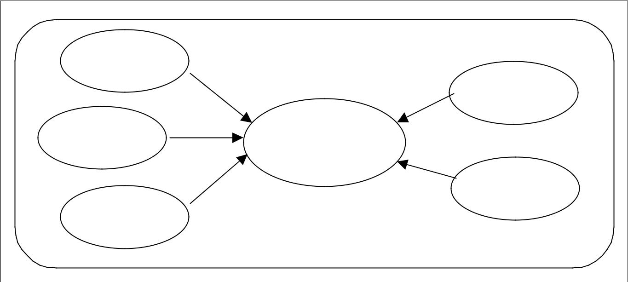

Safety Culture
ulture
Safety Culture |  | Culture of
 |  | Culture of shifts
 |  | shifts / work
 |  | / work groups
 |  | groups
Technical Culture | i ti ’s
Technical Culture | Organisation’s
chnic l | Organisation’s
 | re
 | Culture | Culture of
 |  | Culture of
 |  | company
Business Culture |  | company sites
Business Culture |  | sites
Business Culture | CultureofofthetheAircraftMaintenanceance
C | CultureofofthetheAircraftMaintenanceance
 | Engineering Industryry as a Whole

Figure 15 The influences on an organisation’s culture

5.3 Culture is not necessarily always generated or driven from the top of an organisation (as one might think), but this is the best point from which to influence the culture.

5.4 SAFETY CULTURE

5.4.1 The ICAO Human factors Digest No. 10, “Human Factors, Management and Organisation” (Circular 247), discusses corporate culture and the differences between safe and unsafe corporate cultures.

ICAO HF Digest 10 describes a safety culture as “a set of beliefs, norms, attitudes, roles and social and technical practices concerned with minimising exposure of employees, managers, customers and members of the general public to conditions considered dangerous or hazardous”

The culture of an organisation can best be judged by what is done rather than by what is said. Organisations may have grand ‘mission statements’ concerning safety but this does not indicate that they have a good safety culture unless the policies preached at the top are actually put into practise at the lower levels. It may be difficult to determine the safety culture of an organisation by auditing the procedures and paperwork; a better method is to find out what the majority of the staff actually believe and do in practice.

A method for measuring attitudes to safety has been developed by the Health and Safety Executive utilising a questionnaire approach. Examples of the statements which employees are asked the extent to which they agree are:

- It is necessary to bend some rules to achieve a target;

- Short cuts are acceptable when they involve little or no risk;

- I often come across situations with which I am unfamiliar;

- I sometimes fail to understand which rules apply;

- I am not given regular break periods when I do repetitive and boring jobs;

- There are financial rewards to be gained from breaking the rules.

The results are scored and analysed to give an indication of the safety culture of the organisation, broken down according to safety commitment, supervision, work conditions, logistic support, etc. In theory, this enables one organisation to be objectively compared with another.

5.4.4 Professor James Reason describes the key components of a safety culture summarised as follows:

  - The ‘engine’ that continues to propel the system towards the goal of maximum safety health, regardless of the leadership’s personality or current commercial concerns;

  - Not forgetting to be afraid;

  - Creating a safety information system that collects, analyses and disseminates information from incidents and near-misses as well as from regular proactive checks on the system’s vital signs;

  - A good reporting culture, where staff are willing to report near-misses;

  - A just culture - an atmosphere of trust, where people are encouraged, even rewarded, for providing essential safety related information - but in which they are clear about where the line must be drawn between acceptable and unacceptable behaviour;

  - A flexible culture;

  - Respect for the skills, experience and abilities of the workforce and first line supervisors;

  - Training investment;

  - A learning culture - the willingness and the competence to draw the right conclusions from its safety information system, and the will to implement major reforms when their need is indicated.

5.5 SOCIAL CULTURE

The influence of social culture (an individual’s background or heritage) can be important in determining how an individual integrates into an organisational culture. The way an individual behaves outside an organisation is likely to have a bearing on how they behave within it. Internal pressures and conflicts within groups at work can be driven by underlying social cultural differences (e.g. different nationalities, different political views, different religious beliefs, etc.). This is an extremely complex subject, however, and in-depth discussion is beyond the scope of this text.

Whilst safety culture has been discussed from the organisational perspective, the responsibility of the individual should not be overlooked. Ultimately, safety culture is an amalgamation of the attitude, beliefs and actions of all the individuals working for the organisation and each person should take responsibility for their own contribution towards this culture, ensuring that it is a positive contribution rather than a negative one.

- TEAM WORKING
The responsibility of aircraft maintenance engineers within teams has been discussed in section 2 and the influence of peers on the behaviour of the individual highlighted in section 4. This section looks in more detail at team working in aircraft maintenance.

6.1 THE CONCEPT OF A TEAM

6.1.1 A lot has been written on the concept of a team, and it is beyond the scope of this document to give anything but a flavour of this.

Whereas individualism encourages independence, teams are associated with interdependence and working together in some way to achieve one or more goals.

6.1.2 Teams may comprise a number of individuals working together towards one shared goal. Alternatively, they may consist of a number of individuals working in parallel to achieve one common goal. Teams generally have a recognised leader and one or more follower(s). Teams need to be built up and their identity as a team needs to be maintained in some way.

6.2 SOME ADVANTAGES AND DISADVANTAGES OF TEAM WORKING

6.2.1 The discussion on motivation suggests that individuals need to feel part of a social group. In this respect, team working is advantageous. However, the work on conformity suggests that they feel some pressure to adhere to a group’s views, which may be seen as a potential disadvantage.

6.2.2 Working as part of a team has a number of potential benefits which include:

- individuals can share resources (knowledge, tools, etc.);

- they can discuss problems and arrive at shared solutions;

- they can check each others’ work (either “officially” or “unofficially”).

6.2.3 Teams can be encouraged to take ownership of tasks at the working level. This gives a team greater responsibility over a package of work, rather than having to keep referring to other management for authorisation, support or direction. However, groups left to their own devices need proper leadership (discussed in section 7). Healthy competition and rivalry between teams can create a strong team identity and encourage pride in the product of a team. Team identity also has the advantage that a group of engineers know one another’s capabilities (and weaknesses).

6.2.4 As noted in section 2, if work has to be handed over to another group or team (e.g. shift handover), this can cause problems if it is not handled correctly. If one team of engineers consider that their diligence (i.e. taking the trouble to do something properly and carefully) is a waste of time because an incoming team’s poor performance will detract from it, then it is likely that diligence will become more and more rare over time.

6.3 IMPORTANT ELEMENTS OF TEAM WORKING

For teams to function cohesively and productively, team members need to have or build up certain interpersonal and social skills. These include communication, co-operation, co-ordination and mutual support

6.3.1 Communication

Communication is essential for exchanging work-related information within the team. For example, a team leader must ensure that a team member has not just heard an instruction, but understood what is meant by it. A team member must highlight problems to his colleagues and/or team leader. Furthermore, it is important to listen to what others say. This is covered in greater depth in Chapter 7.

6.3.2 Co-operation

‘Pulling together’ is inherent in the smooth running of a team. Fairness and openness within the team encourage cohesiveness and mutual respect. Disagreements must be handled sensitively by the team leader.

6.3.3 Co-ordination

Co-ordination is required within the team to ensure that the team leader knows what his group members are doing. This includes delegation of tasks so that all the resources within the team are utilised. Delegated tasks should be supervised and monitored as required. The team leader must ensure that no individual is assigned a task beyond his capabilities. Further important aspects of co-ordination are agreement of responsibilities (i.e. who should accomplish which tasks and within what timescale), and prioritisation of tasks.

6.3.4 Mutual Support

- Mutual support is at the heart of the team’s identity. The team leader must engender this in his team. For instance, if mistakes are made, these should be discussed and corrected constructively.

- It is worth noting that in many companies, line engineers tend to work as individuals whereas base engineers tend to work in teams. This may be of significance when an engineer who normally works in a hangar, finds himself working on the line, or vice versa. This was the case in the Boeing 737 incident¹ involving double engine oil pressure loss, where the Base Controller took over a job from the Line Maintenance engineer, along with the line maintenance paperwork. The line maintenance paperwork is not designed for recording work with a view to a handover, and this was a factor when the job was handed over from the Line engineer to the Base Controller.

- MANAGEMENT, SUPERVISION AND LEADERSHIP

The previous section made frequent reference to the team leader. Management, supervision and leadership are all skills that a team leader requires. Of course, management is also a function within an organisation (i.e. those managers responsible for policy, business decisions, etc.), as is the supervisor (i.e. in an official role overseeing a team).

Managers and supervisors have a key role to play in ensuring that work is carried out safely. It is no good instilling the engineers and technicians with ‘good safety practice’ concepts, if these are not supported by their supervisors and managers.

7.1 The Management Role

Line Managers, particularly those working as an integral part of the ‘front line’ operation, may be placed in a situation where they may have to compromise between commercial drivers and ‘ideal’ safety practices (both of which are passed down from ‘top management’ in the organisation). For example, if there is a temporary staff shortage, he must decide whether maintenance tasks can be safely carried out with reduced manpower, or he must decide whether an engineer volunteering to work a “ghoster” to make up the numbers will be able to perform adequately. The adoption of Safety Management Principles¹ may help by providing Managers with techniques whereby they can carry out a more objective assessment of risk.

7.2 The Supervisory Role

7.2.1 Supervision may be a formal role or post (i.e. a Supervisor), or an informal arrangement in which a more experienced engineer ‘keeps an eye on’ less experienced staff. The Supervisor is in a position not only to watch out for errors which might be made by engineers and technicians, but will also have a good appreciation of individual engineer’s strengths and weaknesses, together with an appreciation of the norms and safety culture of the group which he supervises. It is mainly his job to prevent unsafe norms from developing, and to ensure that good safety practices are maintained. There can be a risk however, that the Supervisor becomes drawn down the same cultural path as his team without realising. It is good practice for a Supervisor to step back from the day-to-day work on occasion and to try to look at his charges’ performance objectively.

7.2.2 It can be difficult for supervisory and management staff to strike the right balance between carrying out their supervisory duties and maintaining their engineering skills and knowledge (and appropriate authorisations), and they may get out of practice. In the UK Air Accidents Investigation Branch (AAIB) investigation reports of the BAC 1-11, A320 and B737 incidents, a common factor was: “Supervisors tackling long duration, hands-on involved tasks²”. In the B737 incident, the borescope inspection was carried out by the Base Controller, who needed to do the task in order to retain his borescope authorisation. Also, there is unlikely to be anyone monitoring or checking the Supervisor, because:

- of his seniority;

- he is generally authorised to sign for his own work (except, of course, in the case where a duplicate inspection is required);

- he may often have to step in when there are staff shortages and, therefore, no spare staff to monitor or check the tasks;

- he may be ‘closer’ (i.e. more sensitive to) to any commercial pressures which may exist, or may perceive that pressure to a greater extent than other engineers.

7.2.3 It is not the intention to suggest that supervisors are more vulnerable to error; rather that the circumstances which require supervisors to step in and assist tend to be those where several of the ‘defences’ (see Chapter 8 - error) have already failed and which may result in a situation which is more vulnerable to error.

7.3 CHARACTERISTICS OF A LEADER

7.3.1 There are potentially two types of leader in aircraft maintenance: the person officially assigned the team leader role (possibly called the Supervisor), an individual within a

A leader in a given situation is a person whose ideas and actions influence the thought and the behaviour of others.

7.3.2 A good leader in the maintenance engineering environment needs to possess a number of qualities:

- Motivating his team;

- Reinforcing good attitudes and behaviour;

- Demonstrating by example;

- Maintaining the group;

- Fulfilling a management role.

7.3.3 These will now be examined in a little more detail:

7.3.4 Motivating the Team

Just as the captain of a football team motivates his fellow players, the leader of a maintenance team must do likewise. This can be done by ensuring that the goals or targets of the work which need to be achieved are clearly communicated and manageable. For instance, the team leader would describe the work required on an aircraft within a shift. He must be honest and open, highlighting any potential problems and where appropriate encouraging team solutions.

7.3.5 Reinforcing Good Attitudes and Behaviour

When team members work well (i.e. safely and efficiently), this must be recognised by the team leader and reinforced. This might be by offering a word of thanks for hard work, or making a favourable report to senior management on an individual. A good leader will also make sure that bad habits are eliminated and inappropriate actions are constructively criticised.

7.3.6 Demonstrating by Example

A key skill for a team leader is to lead by example. This does not necessarily mean that a leader must demonstrate that he is adept at a task as his team (it has already been noted that a Supervisor may not have as much opportunity to practise using their skills). Rather, he must demonstrate a personal understanding of the activities and goals of the team so that the team members respect his authority. It is particularly important that the team leader establishes a good safety culture within a team through his attitude and actions in this respect.

7.3.7 Maintaining the Group

Individuals do not always work together as good teams. It is part of the leader’s role to be sensitive to the structure of the team and the relationships within it. He must engender a ‘team spirit’ where the team members support each other and feel responsible for the work of the team. He must also recognise and resolve disputes within the team and encourage co-operation amongst its members.

7.3.8 Fulfilling a Management Role

The team leader must not be afraid to lead (and diplomatically making it clear when necessary that there cannot be more than one leader in a team). The team leader is the link between higher levels of management within the organisation and the team

members who actually work on the aircraft. He is responsible for co-ordinating the activities of the team on a day-to-day basis, which includes allocation of tasks and delegation of duties. There can be a tendency for team members to transfer some of their own responsibilities to the team leader, and he must be careful to resist this.

Skilled management, supervision and leadership play a significant part in the attainment of safety and high quality human performance in aircraft maintenance engineering.

Chapter 9.4 FACTORS AFFECTING PERFORMANCE

The performance abilities and limitations of aircraft maintenance engineers have been described in Chapter 2. Other factors may also impinge on the engineer, potentially rendering him less able to carry out his work and attain the levels of safety required. These include fitness and health, stress, time pressures, workload, fatigue and the effects of medication, alcohol and drugs. These subjects are discussed in this chapter.

- FITNESS AND HEALTH

1.1 The job of an aircraft maintenance engineer can be physically demanding. In addition, his work may have to be carried out in widely varying physical environments, including cramped spaces, extremes of temperature, etc. (as discussed in the next chapter). There are at present no defined requirements for physical or mental fitness for engineers or maintenance staff. ICAO Annex 1¹ states:

“An applicant shall, before being issued with any licence or rating [for personnel other than flight crew members], meet such requirements in respect of age, knowledge, experience and, where appropriate, medical fitness and skill, as specified for that licence or rating.”

1.2 In the UK, the ICAO requirements are enforced through the provision of Article 13 (paragraph 7) of the Air Navigation order (ANO)². This states:

“The holder of an aircraft maintenance engineer’s licence shall not exercise the privileges of such a licence if he knows or suspects that his physical or mental condition renders him unfit to exercise such privileges.”

1.3 There are two aspects to fitness and health: the disposition of the engineer prior to taking on employment and the day-to-day well being of the engineer once employed.

1.4 PRE-EMPLOYMENT DISPOSITION

Some employers may require a medical upon commencement of employment. This allows them to judge the fitness and health of an applicant (and this may also satisfy some pension or insurance related need). There is an obvious effect upon an engineer’s ability to perform maintenance or carry out inspections if through poor physical fitness or health he is constrained in some way (such as his freedom of movement, or his sight). In addition, an airworthiness authority, when considering issuing a licence, will consider these factors and may judge the condition to be of such significance that a licence could not be issued. This would not, however, affect the individual’s possibility of obtaining employment in an alternative post within the industry where fitness and health requirements are less stringent.

1.5 DAY-TO-DAY FITNESS AND HEALTH

1.5.1 Fitness and health can have a significant affect upon job performance (both physical and cognitive). Day-to-day fitness and health can be reduced through illness (physical or mental) or injury.

JAR 66.50 imposes a requirement that “certifying staff must not exercise the privileges of their certification authorisation if they know or suspect that their physical or mental condition renders them unfit.”

1.5.2 Responsibility falls upon the individual aircraft maintenance engineer to determine whether he is not well enough to work on a particular day. Alternatively, his colleagues or supervisor may persuade or advise him to absent himself until he feels better. In fact, as the CAA’s Airworthiness Notice No. 47 (AWN47)¹ points out, it is a legal requirement for aircraft maintenance engineers to make sure they are fit for work:

“Fitness: In most professions there is a duty of care by the individual to assess his or her own fitness to carry out professional duties. This has been a legal requirement for some time for doctors, flight crew members and air traffic controllers. Licensed aircraft maintenance engineers are also now required by law to take a similar professional attitude. Cases of subtle physical or mental illness may not always be apparent to the individual but as engineers often work as a member of a team any sub-standard performance or unusual behaviour should be quickly noticed by colleagues or supervisors who should notify management so that appropriate support and counselling action can be taken.”

1.5.3 Many conditions can impact on the health and fitness of an engineer and there is not space here to offer a complete list. However, such a list would include:

- Minor physical illness (such as colds, ‘flu, etc.);

- More major physical illness (such as HIV, malaria, etc.);

- Mental illness (such as depression, etc.);

- Minor injury (such as a sprained wrist, etc.);

- Major injury (such as a broken arm, etc.);

- Ongoing deterioration in physical condition, possibly associated with the ageing process (such as hearing loss, visual defects, obesity, heart problems, etc.);

- Affects of toxins and other foreign substances (such as carbon monoxide poisoning, alcohol, illicit drugs, etc.).

1.5.4 This document does not attempt to give hard and fast guidelines as to what constitutes ‘unfit for work’; this is a complex issue dependent upon the nature of the illness or condition, its effect upon the individual, the type of work to be done, environmental conditions, etc. Instead, it is important that the engineer is aware that his performance, and consequently the safety of aircraft he works on, might be affected adversely by illness or lack of fitness.

1.5.5 An engineer may consider that he is letting down his colleagues by not going to work through illness, especially if there are ongoing manpower shortages. However, he should remind himself that, in theory, management should generally allow for contingency for illness. Hence the burden should not be placed upon an individual to
turn up to work when unfit if no such contingency is available. Also, if the individual has a contagious illness (e.g. ‘flu), he may pass this on to his colleagues if he does not absent himself from work and worsen the manpower problem in the long run. There can be a particular problem with some contract staff due to loss of earnings or even loss of contract if absent from work due to illness. They may be tempted to disguise their illness, or may not wish to admit to themselves or others that they are ill. This is of course irresponsible, as the illness may well adversely affect the contractor’s standard of work.

1.6 POSITIVE MEASURES

1.6.1 Aircraft maintenance engineers can take common sense steps to maintain their fitness and health. These include:

- Eating regular meals and a well-balanced diet;

- Taking regular exercise (exercise sufficient to double the resting pulse rate for 20 minutes, three times a week is often recommended);

- Stopping smoking;

- Sensible alcohol intake (for men, this is no more than 3 - 4 units a day or 28 per week, where a unit is equivalent to half a pint of beer or a glass of wine or spirit);

1.6.2 Finally, day-to-day health and fitness can be influenced by the use of medication, alcohol and illicit drugs. These are covered later in Section 6.

- Stress: Domestic and Work Related

2.1 Stress is an inescapable part of life for all of us.

Stress can be defined as any force, that when applied to a system, causes some significant modification of its form, where forces can be physical, psychological or due to social pressures.

Source: Penguin Dictionary of Psychology¹

2.2 From a human viewpoint, stress results from the imposition of any demand or set of demands which require us to react, adapt or behave in a particular manner in order to cope with or satisfy them. Up to a point, such demands are stimulating and useful, but if the demands are beyond our personal capacity to deal with them, the resulting stress is a problem.

2.3 Causes and Symptoms

2.3.1 Stress is usually something experienced due to the presence of some form of stressor, which might be a one-off stimulus (such as a challenging problem or a punch on the nose), or an on-going factor (such as an extremely hot hangar or an acrimonious divorce). From these, we get acute stress (typically intense but of short duration) and chronic stress (frequent recurrence or of long duration) respectively.

2.3.2 Different stressors affect different people to varying extents. Stressors may be:

- Physical - such as heat, cold, noise, vibration, presence of something damaging to health (e.g. carbon monoxide);

- Psychological - such as emotional upset (e.g. due to bereavements, domestic problems, etc.), worries about real or imagined problems (e.g. due to financial problems, ill health, etc.);

- Reactive - such as events occurring in everyday life (e.g. working under time pressure, encountering unexpected situations, etc.).

2.3.3 AWN47 points out that:

“A stress problem can manifest itself by signs of irritability, forgetfulness, sickness absence, mistakes, or alcohol or drug abuse. Management have a duty to identify individuals who may be suffering from stress and to minimise workplace stresses. Individual cases can be helped by sympathetic and skilful counselling which allows a return to effective work and licensed duties.”

2.3.4 In brief, the possible signs of stress can include:

- Physiological symptoms - such as sweating, dryness of the mouth, etc.;

- Health effects - such as nausea, headaches, sleep problems, diarrhoea, ulcers, etc.;

- Behavioural symptoms - such as restlessness, shaking, nervous laughter, taking longer over tasks, changes to appetite, excessive drinking, etc.;

- Cognitive effects - such as poor concentration, indecision, forgetfulness, etc.;

- Subjective effects - such as anxiety, irritability, depression, moodiness, aggression, etc.

It should be noted that individuals respond to stressful situations in very different ways. Generally speaking though, people tend to regard situations with negative consequences as being more stressful than when the outcome of the stress will be positive (e.g. the
difference between being made redundant from work and being present at the birth of a son or daughter).

2.4 Domestic Stress

2.4.1 When aircraft maintenance engineers go to work, they cannot leave stresses associated with home behind. Pre-occupation with a source of domestic stress can play on one’s mind during the working day, distracting from the working task. Inability to concentrate fully may impact on the engineer’s task performance and ability to pay due attention to safety.

2.4.2 Domestic stress typically results from major life changes at home, such as marriage, birth of a child, a son or daughter leaving home, bereavement of a close family member or friend, marital problems, or divorce.

2.5 Work Related Stress

2.5.1 Aircraft maintenance engineers can experience stress for two reasons at work: because of the task or job they are undertaking at that moment, or because of the general organisational environment. Stress can be felt when carrying out certain tasks that are particularly challenging or difficult. This stress can be increased by lack of guidance in this situation, or time pressures to complete the task or job (covered later in this chapter). This type of stress can be reduced by careful management, good training, etc.

2.5.2 Within the organisation, the social and managerial aspects of work can be stressful. Chapter 3 discussed the impact on the individual of peer pressure, organisational culture and management, all of which can be stressors. In the commercial world that aircraft maintenance engineers work in, shift patterns, lack of control over own workload, company reorganisation and job uncertainty can also be sources of stress.

2.6 Stress Management

2.6.1 Once we become aware of stress, we generally respond to it by using one of two strategies: defence or coping.

Defence strategies involve alleviation of the symptoms (taking medication, alcohol, etc.) or reducing the anxiety (e.g. denying to yourself that there is a problem (denial), or blaming someone else).

2.6.2 Coping strategies involve dealing with the source of the stress rather than just the symptoms (e.g. delegating workload, prioritising tasks, sorting out the problem, etc.).

Coping is the process whereby the individual either adjusts to the perceived demands of the situation or changes the situation itself.

Source: Green, R.G. et al (1996)¹

2.6.3 Unfortunately, it is not always possible to deal with the problem if this is outside the control of the individual (such as during an emergency), but there are well-published techniques for helping individuals to cope with stress². Good stress management techniques include:

- Relaxation techniques;

- Careful regulation of sleep and diet;

- A regime of regular physical exercise;

- Counselling - ranging from talking to a supportive friend or colleague to seeking professional advice.

2.6.4 There is no magic formula to cure stress and anxiety, merely common sense and practical advice.

- TIME PRESSURE AND DEADLINES

3.1 There is probably no industry in the commercial environment that does not impose some form of deadline, and consequently time pressure, on its employees. Aircraft maintenance is no exception. It was highlighted in the previous section that one of the potential stressors in maintenance is time pressure. This might be actual pressure where clearly specified deadlines are imposed by an external source (e.g. management or supervisors) and passed on to engineers, or perceived where engineers feel that there are time pressures when carrying out tasks, even when no definitive deadlines have been set in stone. In addition, time pressure may be self-imposed, in which case engineers set themselves deadlines to complete work (e.g. completing a task before a break or before the end of a shift).

3.2 Management have contractual pressures associated with ensuring an aircraft is released to service within the time frame specified by their customers. Striving for higher aircraft utilisation means that more maintenance must be accomplished in fewer hours, with these hours frequently being at night. Failure to do so can impact on flight punctuality and passenger satisfaction. Thus, aircraft maintenance engineers have two driving forces: the deadlines handed down to them and their responsibilities to carry out a safe job. The potential conflict between these two driving pressures can cause problems.

3.3 The Effects of Time Pressure and Deadlines

As with stress, it is generally thought that some time pressure is stimulating and may actually improve task performance. However, it is almost certainly true that excessive time pressure (either actual or perceived, external or self-imposed), is likely to mean that due care and attention when carrying out tasks diminishes and more errors will be made. Ultimately, these errors can lead to aircraft incidents and accidents.

It is possible that perceived time pressure would appear to have been a contributory factor in the BAC 1-11 accident described in Chapter 1. Although the aircraft was not required the following morning for operational use, it was booked for a wash. The wash team had been booked the previous week and an aircraft had not been ready. This would have happened again, due to short-staffing, so the Shift Manager decided to carry out the windscreen replacement task himself so that the aircraft would be ready in time.

3.4 Managing Time Pressure and Deadlines

3.4.1 One potential method of managing time pressures exerted on engineers is through regulation. For example, FAA research has highlighted the need to insulate aircraft maintenance engineers from commercial pressures. They consider this would help to ensure that airworthiness issues will always take precedence over commercial and time pressures. Time pressures can make ‘corner-cutting’ a cultural norm in an organisation. Sometimes, only an incident or accident reveals such norms (the extract from the Aloha accident above exemplifies this).

3.4.2 Those responsible for setting deadlines and allocating tasks should consider:

- Prioritising various pieces of work that need to be done;

- The actual time available to carry out work (considering breaks, shift handovers, etc.);

- The personnel available throughout the whole job (allowing a contingency for illness);

- The most appropriate utilisation of staff (considering an engineer’s specialisation, and strengths and limitations);

- Availability of parts and spares.

It is important that engineering staff at all levels are not afraid to voice concerns over inappropriate deadlines, and if necessary, cite the need to do a safe job to support this. As highlighted in Chapter 3, within aircraft maintenance, responsibility should be spread across all those who play a part. Thus, the aircraft maintenance engineer should not feel that the ‘buck stops here’.

- WORKLOAD - OVERLOAD AND UNDERLOAD

4.1 The preceding sections on stress and time pressure have both indicated that a certain amount of stimulation is beneficial to an aircraft maintenance engineer, but that too much stimulation can lead to stress or over-commitment in terms of time. It is noteworthy that too little stimulation can also be a problem.

4.2 Before going on to discuss workload, it is important to consider this optimum level of stimulation or arousal.

4.3 Arousal

4.3.1 Arousal in its most general sense, refers to readiness of a person for performing work. To achieve an optimum level of task performance, it is necessary to have a certain level of stimulation or arousal. This level of stimulation or arousal varies from person to person. There are people who are overloaded by having to do more than one task at a time; on the other hand there are people who appear to thrive on stress, being happy to take on more and more work or challenges. Figure 16 shows the general relationship between arousal and task performance

Performance
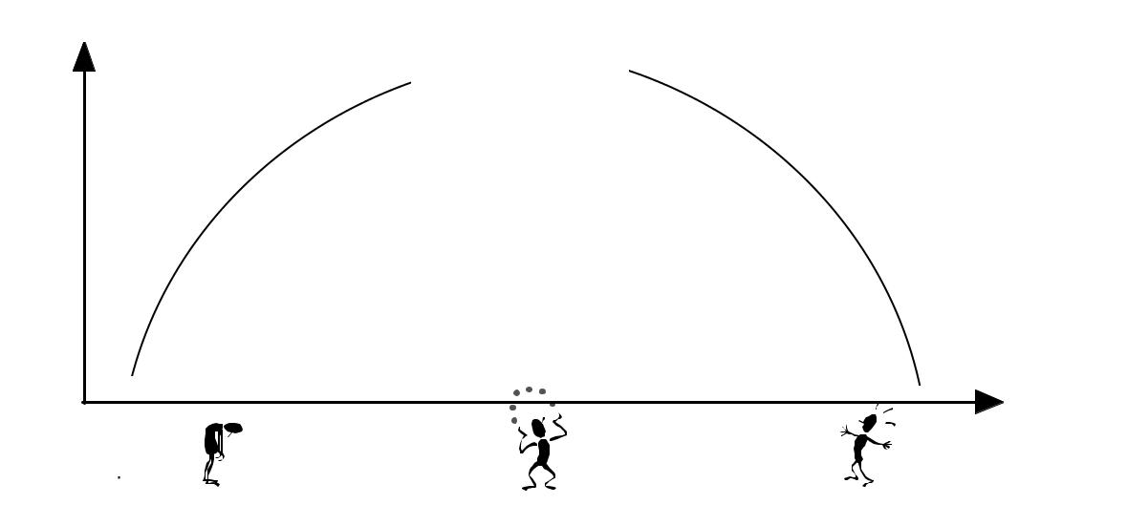
Good

Performance

Poor |  | Poor
Performance |  | Performance

Level of
Arousal

Under - Aroused Optimum Arousal Over - Aroused

Figure 16 Optimum arousal leads to best task performance (adapted from Thom
1999)¹

- Thom, T. (1999) The Pilot’s Manual Volume 6: Human Factors and Pilot Performance (3rd edition).

Shrewsbury: Airlife Publishing.

4.3.2 At low levels of arousal, our attentional mechanisms will not be particularly active and our performance capability will be low (complacency and boredom can result). At the other end of the curve, performance deteriorates when arousal becomes too high. To a certain extent, this is because we are forced to shed tasks and focus on key information only (called narrowing of attention). Best task performance occurs somewhere in the middle.

4.3.3 In the work place, arousal is mainly influenced by stimulation due to work tasks. However, surrounding environmental factors such as noise may also influence the level of arousal.

4.4 Factors Determining Workload

4.4.1 An individual aircraft maintenance engineer can usually identify what work he has to do quite easily. It is more difficult to assess how that work translates into workload.

The degree of stimulation exerted on an individual caused by a task is generally referred to as workload, and can be separated into physical workload and mental workload.

4.4.2 As noted in the section on information processing in Chapter 2, humans have limited mental capacity to deal with information. We are also limited physically, in terms of visual acuity, strength, dexterity and so on. Thus, workload reflects the degree to which the demands of the work we have to do eats into our mental and physical capacities. Workload is subjective (i.e. experienced differently by different people) and is affected by:

- The nature of the task, such as the:

  - physical demands it requires (e.g. strength required, etc.);

  - mental demands it requires (e.g. complexity of decisions to be made, etc.).

- The circumstances under which the task is performed, such as the:

  - standard of performance required (i.e. degree of accuracy);

  - time available to accomplish the task (and thus the speed at which the task must be carried out);

  - requirement to carry out the task at the same time as doing something else;

  - perceived control of the task (i.e. is it imposed by others or under your control, etc.);

  - environmental factors existing at time (e.g. extremes of temperature, etc.).

- The person and his state, such as his:

  - skills (both physical and mental);

  - his experience (particularly familiarity with the task in question);

  - his current health and fitness levels;

  - his emotional state (e.g. stress level, mood, etc.).

4.4.3 As the workload of the engineer may vary, he may experience periods of overload and underload. This is a particular feature of some areas of the industry such as line maintenance.

4.5 Overload

Overload occurs at very high levels of workload (when the engineer becomes over aroused). As highlighted previously, performance deteriorates when arousal becomes too high and we are forced to shed tasks and focus on key information. Error rates may also increase. Overload can occur for a wide range of reasons based on the factors highlighted above. It may happen suddenly (e.g. if asked to remember one further piece of information whilst already trying to remember a large amount of data), or gradually.

the work that is intended to be carried out”¹, this does not prevent individuals from becoming overloaded. As noted earlier in this section, it can be difficult to determine how work translates into workload, both for the individual concerned, and for those allocating tasks.

4.6 Underload

Underload occurs at low levels of workload (when the engineer becomes under aroused). It can be just as problematic to an engineer as overload, as it too causes a deterioration in performance and an increase in errors, such as missed information. Underload can result from a task an engineer finds boring, very easy, or indeed a lack of tasks. The nature of the aircraft maintenance industry means that available work fluctuates, depending on time of day, maintenance schedules, and so forth. Hence, unless stimulating ‘housekeeping’ tasks can be found, underload can be difficult to avoid at times.

4.7 Workload Management

4.7.1 Unfortunately, in a commercial environment, it is seldom possible to make large amendments to maintenance schedules, nor eliminate time pressures. The essence of workload management in aircraft maintenance should include:

- ensuring that staff have the skills needed to do the tasks they have been asked to do and the proficiency and experience to do the tasks within the timescales they have been asked to work within;

- making sure that staff have the tools and spares they need to do the tasks;

- allocating tasks to teams or individual engineers that are accomplishable (without cutting corners) in the time available;

- providing human factors training to those responsible for planning so that the performance and limitations of their staff are taken into account;

- encouraging individual engineers, supervisors and managers to recognise when an overload situation is building up.

4.7.2 If an overload situation is developing, methods to help relieve this include:

- seeking a simpler method of carrying out the work (that is just as effective and still legitimate);

- delegating certain activities to others to avoid an individual engineer becoming overloaded;

- securing further time in order to carry out the work safely;

- postponing, delaying tasks/deadlines and refusing additional work.

4.7.3 Thus, although workload varies in aircraft maintenance engineering, the workload of engineers can be moderated. Much of this can be done by careful forward planning of tasks, manpower, spares, tools and training of staff.

- SLEEP, FATIGUE AND SHIFT WORK

5.1 What Is Sleep?

5.1.1 Man, like all living creatures has to have sleep. Despite a great deal of research, the purpose of sleep is not fully understood.

Sleep is a natural state of reduced consciousness involving changes in body and brain physiology which is necessary to man to restore and replenish the body and brain.

5.1.2 Sleep can be resisted for a short time, but various parts of the brain ensure that sooner or later, sleep occurs. When it does, it is characterised by five stages of sleep:

- Stage 1: This is a transitional phase between waking and sleeping. The heart rate slows and muscles relax. It is easy to wake someone up.

- Stage 2: This is a deeper level of sleep, but it is still fairly easy to wake someone.

- Stage 3: Sleep is even deeper and the sleeper is now quite unresponsive to external stimuli and so is difficult to wake. Heart rate, blood pressure and body temperature continue to drop.

- Stage 4: This is the deepest stage of sleep and it is very difficult to wake someone up.

- Rapid Eye Movement or REM Sleep: Even though this stage is characterised by brain activity similar to a person who is awake, the person is even more difficult to awaken than stage 4. It is therefore also known as paradoxical sleep. Muscles become totally relaxed and the eyes rapidly dart back and forth under the eyelids. It is thought that dreaming occurs during REM sleep.

5.1.3 Stages 1 to 4 are collectively known as non-REM (NREM) sleep. Stages 2-4 are categorised as slow-wave sleep and appear to relate to body restoration, whereas REM sleep seems to aid the strengthening and organisation of memories. Sleep deprivation experiments suggest that if a person is deprived of stage 1-4 sleep or REM sleep he will show rebound effects. This means that in subsequent sleep, he will make up the deficit in that particular type of sleep. This shows the importance of both types of sleep.

5.1.4 As can be seen from Figure 17, sleep occurs in cycles. Typically, the first REM sleep will occur about 90 minutes after the onset of sleep. The cycle of stage 1 to 4 sleep and REM sleep repeats during the night about every 90 minutes. Most deep sleep occurs earlier in the night and REM sleep becomes greater as the night goes on.

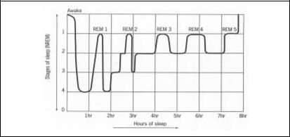

Figure 17 Typical cycle of stage 1-4 (NREM) sleep and REM sleep in the course of a night. Source: Gross, 1996¹

5.2 CIRCADIAN RHYTHMS

5.2.1 Apart from the alternation between wakefulness and sleep, man has other internal cycles, such as body temperature and hunger/eating. These are known as circadian rhythms as they are related to the length of the day.

Circadian rhythms are physiological and behavioural functions and processes in the body that have a regular cycle of approximately a day (actually about 25 hours in man).

5.2.2 Although, circadian rhythms are controlled by the brain, they are influenced and synchronised by external (environmental) factors such as light.

An example of disrupting circadian rhythms would be taking a flight that crosses time zones. This will interfere with the normal synchronisation with the light and dark (day/ night). This throws out the natural link between daylight and the body’s internal clock, causing jet lag, resulting in sleepiness during the day, etc. Eventually however, the circadian rhythm readjusts to the revised environmental cues.

5.2.3 Figure 18 shows the circadian rhythm for body temperature. This pattern is very robust, meaning that even if the normal pattern of wakefulness and sleep is disrupted (by shift work for example), the temperature cycle remains unchanged. Hence, it can be seen that if you are awake at 4-6 o’clock in the morning, your body temperature is in a trough and it is at this time that is hardest to stay awake. Research has shown that this drop in body temperature appears to be linked to a drop in alertness and performance in man.

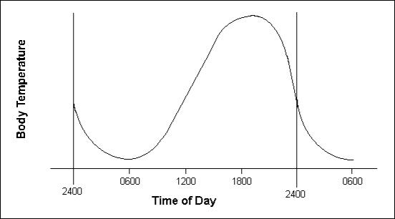

Figure 18 The Circadian Rhythm for Internal Body Temperature

Although there are many contributory factors, it is noteworthy that a number of major incidents and accidents involving human error have either occurred or were initiated in the pre-dawn hours, when body temperature and performance capability are both at their lowest. These include Three Mile Island, Chernobyl, and Bhopal, as well as the BAC1-11, A320, and B737 incidents summarised in Chapter 1.

5.2.4 The engineer’s performance at this ‘low point’ will be improved if he is well rested, feeling well, highly motivated and well practised in the skills being used at that point.

5.3 Fatigue

5.3.1 Fatigue can be either physiological or subjective. Physiological fatigue reflects the body’s need for replenishment and restoration. It is tied in with factors such as recent physical activity, current health, consumption of alcohol, and with circadian rhythms. It can only be satisfied by rest and eventually, a period of sleep. Subjective fatigue is an individual’s perception of how sleepy they feel. This is not only affected by when they last slept and how good the sleep was but other factors, such as degree of motivation.

5.3.2 Fatigue is typically caused by delayed sleep, sleep loss, desynchronisation of normal circadian rhythms and concentrated periods of physical or mental stress or exertion. In the workplace, working long hours, working during normal sleep hours and working on rotating shift schedules all produce fatigue to some extent.

5.3.3 Symptoms of fatigue (in no particular order) may include:

- diminished perception (vision, hearing, etc.) and a general lack of awareness;

- diminished motor skills and slow reactions;

- problems with short-term memory;

- channelled concentration - fixation on a single possibly unimportant issue, to the neglect of others and failing to maintain an overview;

- being easily distracted by unimportant matters;

- poor judgement and decision making leading to increased mistakes;

- abnormal moods - erratic changes in mood, depressed, periodically elated and energetic;

- diminished standards of own work.

5.3.4 AWN47 highlights the potential for fatigue in aircraft maintenance engineering:

“Tiredness and fatigue can adversely affect performance. Excessive hours of duty and shift working, particularly with multiple shift periods or additional overtime, can lead to problems. Individuals should be fully aware of the dangers of impaired performance due to these factors and of their personal responsibilities.”

5.4 Shift Work

Most aircraft movements occur between 6 a.m. and 10 p.m. to fit in with the requirements of passengers. Aircraft maintenance engineers are required whenever aircraft are on the ground, such as during turn arounds. However, this scheduling means that aircraft are often available for more significant maintenance during the night. Thus, aircraft maintenance engineering is clearly a 24 hour business and it is inevitable that, to fulfil commercial obligations, aircraft maintenance engineers usually work shifts. Some engineers permanently work the same shift, but the majority cycle through different shifts. These typically comprise either an ‘early shift’, a ‘late shift’ and a ‘night shift’, or a ‘day shift’ and a ‘night shift’ depending on the maintenance organisation.

5.4.1 Advantages and Disadvantages of Shift Work

There are pros and cons to working shifts. Some people welcome the variety of working different times associated with regular shift work patterns. Advantages may include more days off and avoiding peak traffic times when travelling to work. The disadvantages of shift working are mainly associated with:

- working ‘unsociable hours’, meaning that time available with friends, family, etc. will be disrupted;

- working when human performance is known to be poorer (i.e. between 4 a.m and 6 a.m.);

- problems associated with general desynchronisation and disturbance of the body’s various rhythms (principally sleeping patterns).

5.4.2 Working At Night

Shift work means that engineers will usually have to work at night, either permanently or as part of a rolling shift pattern. As discussed earlier in this chapter, this introduces the inherent possibility of increased human errors. Working nights can also lead to problems sleeping during the day, due to the interference of daylight and environmental noise. Blackout curtains and use of ear plugs can help, as well as

5.4.3 Rolling Shift Patterns

When an engineer works rolling shifts and changes from one shift to another (e.g. ‘day shift’ to ‘night shift’), the body's internal clock is not immediately reset. It continues on its old wake-sleep cycle for several days, even though it is no longer possible for the person to sleep when the body thinks it is appropriate, and is only gradually resynchronised. However, by this time, the engineer may have moved onto the next shift. Generally, it is now accepted that shift rotation should be to later shifts (i.e. early shift late shift night shift or day shift night shift) instead of rotation towards earlier shifts (night shift late shift early shift).

5.4.4 Continuity of Tasks and Shift Handovers

Many maintenance tasks often span more than one shift, requiring tasks to be passed from one shift to the next. The outgoing personnel are at the end of anything up to a twelve hour shift and are consequently tired and eager to go home. Therefore, shift handover is potentially an area where human errors can occur. Whilst longer shifts may result in greater fatigue, the disadvantages may be offset by the fact that fewer shift changeovers are required (i.e. only 2 handovers with 2 twelve hour shifts, as opposed to 3 handovers with 3 eight hour shifts). Shift handover is discussed further in Chapter 7 when looking at ‘work logging and recording’.

5.5 SLEEP, FATIGUE, SHIFT WORK AND THE AIRCRAFT MAINTENANCE ENGINEER

5.5.1 Most individuals need approximately 8 hours sleep in a 24 hour period, although this varies between individuals, some needing more and some happy with less than this to be fully refreshed. They can usually perform adequately with less that this for a few days, building up a temporary sleep ‘deficit’. However, any sleep deficit will need to be made up, otherwise performance will start to suffer.

A good rule of thumb is that one hour of high-quality sleep is good for two hours of activity.

5.5.2 As previously noted, fatigue is best tackled by ensuring adequate rest and good quality sleep are obtained. The use of blackout curtains if having to sleep during daylight has already been mentioned. It is also best not to eat a large meal shortly before trying to sleep, but on the other hand, the engineer should avoid going to bed hungry. As fatigue is also influenced by illness, alcohol, etc., it is very important to get more sleep if feeling a little unwell and drink only in moderation between duties (discussed further in the next section). Taking over-the-counter drugs to help sleep should only be used as a last resort.

5.5.3 When rotating shifts are worked, it is important that the engineer is disciplined with his eating and sleeping times. Moreover, out of work activities have to be carefully planned. For example, it is obvious that an individual who has been out night-clubbing until the early hours of the morning will not be adequately rested if rostered on an early shift.

5.5.4 Shift working patterns encountered by aircraft maintenance engineers may include three or four days off after the last night shift. It can be tempting to work additional hours, taking voluntary overtime, or another job, in one or more of these days off. This is especially the case when first starting a career in aircraft maintenance engineering when financial pressures may be higher. Engineers should be aware that their vulnerability to error is likely to be increased if they are tired or fatigued, and they should try to ensure that any extra hours worked are kept within reason.

It is always sensible to monitor ones performance, especially when working additional hours. Performance decrements can be gradual, and first signs of chronic fatigue may be moodiness, headaches or finding that familiar tasks (such as programming the video recorder) seem more complicated than usual.

5.5.5 Finally, it is worth noting that, although most engineers adapt to shift working, it becomes harder to work rotating shifts as one gets older.

- ALCOHOL, MEDICATION AND DRUG ABUSE

6.1 It should come as no surprise to the aircraft maintenance engineer that his performance will be affected by alcohol, medication or illicit drugs. Under both UK and JAA legislation it is an offence for safety critical personnel to carry out their duties whilst under the influence of alcohol or drugs. Article 13 (paragraph 8) of the UK ANO, states:

“The holder of an aircraft maintenance engineer’s licence shall not, when exercising the privileges of such a licence, be under the influence of drink or a drug to such an extent as to impair his capacity to exercise such privileges.”

6.2 The current law which does not prescribe a blood/alcohol limit, is soon to change. There will be new legislation permitting police to test for drink or drugs where there is reasonable cause, and the introduction of a blood/alcohol limit of 20 milligrams of alcohol per 100 millilitres of blood for anyone performing a safety critical role in UK civil aviation (which includes aircraft maintenance engineers).

6.3 Alcohol

6.3.1 Alcohol acts as a depressant on the central nervous system, dulling the senses and increasing mental and physical reaction times. It is known that even a small amount of alcohol leads to a decline in an individual’s performance and may cause his judgment (i.e. ability to gauge his performance) to be hindered.

6.3.2 Alcohol is removed from the blood at a fixed rate and this cannot be speeded up in any way (e.g. by drinking strong coffee). In fact, sleeping after drinking alcohol can slow down the removal process, as the body’s metabolic systems are slower.

6.3.3 AWN47 provides the following advice concerning alcohol:

“Alcohol has similar effects to tranquillisers and sleeping tablets and may remain circulating in the blood for a considerable time, especially if taken with food. It may be borne in mind that a person may not be fit to go on duty even 8 hours after drinking large amounts of alcohol. Individuals should therefore anticipate such effects upon their next duty period. Special note should be taken of the fact that combinations of alcohol and sleeping tablets, or anti-histamines, can form a highly dangerous and even lethal combination.”

As a general rule, aircraft maintenance engineers should not work for at least eight hours after drinking even small quantities of alcohol and increase this time if more has been drunk.

6.3.4 The affects of alcohol can be made considerably worse if the individual is fatigued, ill or using medication.

6.4 Medication

6.4.1 Any medication, no matter how common, can possibly have direct effects or side effects that may impair an engineer’s performance in the workplace.

Medication can be regarded as any over-the-counter or prescribed drug used for therapeutic purposes.

6.4.2 There is a risk that these effects can be amplified if an individual has a particular sensitivity to the medication or one of its ingredients. Hence, an aircraft maintenance engineer should be particularly careful when taking a medicine for the first time, and should ask his doctor whether any prescribed drug will affect his work performance. It is also wise with any medication to take the first dose at least 24 hours before any duty to ensure that it does not have any adverse effects.

Medication is usually taken to relieve symptoms of an illness. Even if the drugs taken do not affect the engineer’s performance, he should still ask himself whether the illness has made him temporarily unfit for work.

6.4.3 Various publications, and especially AWN47 give advice relevant to the aircraft maintenance engineer on some of the more common medications. This information is summarised below, however the engineer must use this with caution and should seek further clarification from a pharmacist, doctor or their company occupational health advisor if at all unsure of the impact on work performance.

- Analgesics are used for pain relief and to counter the symptoms of colds and ‘flu. In the UK, paracetamol, aspirin and ibuprofen are the most common, and are
generally considered safe if used as directed. They can be taken alone but are often used as an ingredient of a ‘cold relief’ medicine. It is always worth bearing in mind that the pain or discomfort that you are attempting to treat with an analgesic (e.g. headache, sore throat, etc.) may be the symptom of some underlying illness that needs proper medical attention.

- Antibiotics (such as Penicillin and the various mycins and cyclines) may have short term or delayed effects which affect work performance. Their use indicates that a fairly severe infection may well be present and apart from the effects of these substances themselves, the side-effects of the infection will almost always render an individual unfit for work.

- Anti-histamines are used widely in ‘cold cures’ and in the treatment of allergies (e.g. hayfever). Most of this group of medicines tend to make the user feel drowsy, meaning that the use of medicines containing anti-histamines is likely to be unacceptable when working as an aircraft maintenance engineer.

- Cough suppressants are generally safe in normal use, but if an over-the-counter product contains anti-histamine, decongestant, etc., the engineer should exercise caution about its use when working.

- Decongestants (i.e. treatments for nasal congestion) may contain chemicals such as pseudo-ephedrine hydrochloride (e.g. ‘Sudafed’) and phenylphrine. Side-effects reported, are anxiety, tremor, rapid pulse and headache. AWN47 forbids the use of medications containing this ingredient to aircraft maintenance engineers when working, as the effects compromise skilled performance.

- ‘Pep’ pills are used to maintain wakefulness. They often contain caffeine, dexedrine or benzedrine. Their use is often habit forming. Over-dosage may cause headaches, dizziness and mental disturbances. AWN47 states that “the use of ‘pep’ pills whilst working cannot be permitted. If coffee is insufficient, you are not fit for work.”

- Sleeping tablets (often anti-histamine based) tend to slow reaction times and generally dull the senses. The duration of effect is variable from person to person. Individuals should obtain expert medical advice before taking them.

6.4.4 Melatonin (a natural hormone) deserves a special mention. Although not available without a prescription in the UK, it is classed as a food supplement in the USA (and is readily available in health food shops). It has been claimed to be effective as a sleep aid, and to help promote the resynchronisation of disturbed circadian rhythms. Its effectiveness and safety are still yet to be proven and current best advice is to avoid this product.

If the aircraft maintenance engineer has any doubts about the suitability of working whilst taking medication, he must seek appropriate professional advice.

6.5 Drugs

6.5.1 Illicit drugs such as ecstasy, cocaine and heroin all affect the central nervous system and impair mental function. They are known to have significant effects upon performance and have no place within the aviation maintenance environment. Of course, their possession and use are also illegal in the UK.

6.5.2 Smoking cannabis can subtly impair performance for up to 24 hours. In particular, it affects the ability to concentrate, retain information and make reasoned judgments, especially on difficult tasks.

Chapter 9.5 PHYSICAL ENVIRONMENT

The aircraft maintenance engineer can expect to work in a variety of different environments, from ‘line’ (generally outside the hangar) to ‘base’ (usually inside a hangar or workshop), in all types of weather and climatic conditions, day and night. This depends largely on the company he works for, and the function he fulfils in the company. Both physical environments have their own specific features or factors that may impinge on human performance. This chapter considers the impact of noise, fumes, illumination, climate and temperature, motion and vibration, as well as the requirement to work in confined spaces and issues associated with the general working environment.

- NOISE

1.1 The impact of noise on human performance has already been discussed in Chapter 2, Section 3 when examining ‘hearing’. To recap, noise in the workplace can have both short-term and long-term negative effects: it can be annoying, can interfere with verbal communication and mask warnings, and it can damage workers’ hearing (either temporarily or permanently). It was noted that the ear is sensitive to sounds between certain frequencies (20 HZ to 20 KHz) and that intensity of sound is measured in decibels (dB), where exposure in excess of 115 dB without ear protection even for a short duration is not recommended. This equates to standing within a few hundred metres of a moving jet aircraft.

Noise can be thought of as any unwanted sound, especially if it is loud, unpleasant and annoying.

1.2 General background noise can be ‘filtered out’ by the brain through focused attention (as noted in Chapter 2, Section 3). Otherwise, for more problematic noise, some form of hearing protection (e.g. ear plugs and ear muffs) is commonly used by aircraft maintenance engineers, both on the line and in the hangar, to help the engineer to concentrate.

1.3 The noise environment in which the aircraft maintenance engineer works can vary considerably. For instance, the airport ramp or apron area is clearly noisy, due to running aircraft engines or auxiliary power units (APUs), moving vehicles and so on. It is not unusual for this to exceed 85 dB - 90 dB which can cause hearing damage if the time of exposure is prolonged. The hangar area can also be noisy, usually due to the use of various tools during aircraft maintenance. Short periods of intense noise are not uncommon here and can cause temporary hearing loss. Engineers may move to and from these noisy areas into the relative quiet of rest rooms, aircraft cabins, stores and offices

1.4 In their day-to-day work, aircraft maintenance engineers will often need to discuss matters relating to a task with colleagues and also, at the end of a shift, handover to an incoming engineer. Clearly, in both cases it is important that noise does not impair their ability to communicate, as this could obviously have a bearing on the successful completion of the task (i.e. safety). Common sense dictates that important matters are discussed away from noisy areas.

- FUMES

2.1 By its nature, the maintenance of aircraft involves working with a variety of fluids and chemical substances. For instance, engineers may come across various lubricants (oils and greases), hydraulic fluids, paints, cleaning compounds and solder. They will also be exposed to aircraft fuel and exhaust. In fact, there is every possibility that an engineer could be exposed to a number of these at any one time in the workplace. Each substance gives off some form of vapour or fumes which can be inhaled by the aircraft maintenance engineer. Some fumes will be obvious as a result of their odour, whereas others have no smell to indicate their presence. Some substances will be benign most of the time, but may, in certain circumstances, produce fumes (e.g. overheated grease or oils, smouldering insulation).

2.2 Fumes can cause problems for engineers mainly as a result of inhalation, but they can also cause other problems, such as eye irritation. The problem may be exacerbated in aircraft maintenance engineering by the confined spaces in which work must sometimes be carried out (e.g. fuel tanks). Here the fumes cannot dissipate easily and it may be appropriate to use breathing apparatus.

2.3 It may not always be practical to eradicate fumes from the aircraft maintenance engineer’s work place, but where possible, steps should be taken to minimise them. It is also common sense that if noxious fumes are detected, an engineer should immediately inform his colleagues and supervisor so that the area can be evacuated and suitable steps taken to investigate the source and remove them.

Apart from noxious fumes that have serious health implications and must be avoided, working in the presence of fumes can affect an engineer’s performance, as he may rush a job in order to escape them. If the fumes are likely to have this effect, the engineer should increase the ventilation locally or use breathing apparatus to dissipate the fumes.

- ILLUMINATION

3.1 In order that aircraft maintenance engineers are able to carry out their work safely and efficiently, it is imperative that their work be conducted under proper lighting conditions. It was noted in Chapter 2, Section 2 that the cones in the retina of the eye require good light to resolve fine detail. Furthermore, colour vision requires adequate light to stimulate the cones. Inappropriate or insufficient lighting can lead to mistakes in work tasks or can increase the time required to do the work.

Illumination refers to the lighting both within the general working environment and also in the locality of the engineer and the task he is carrying out. It can be defined as the amount of light striking a surface.

3.2 When working outside during daylight, the engineer may have sufficient natural light to see well by. It is possible however that he may be in shadow (possibly caused by the aircraft) or a building. Similarly, cramped equipment compartments will not be illuminated by ambient hangar lighting. In these cases, additional local artificial lighting is usually required (known as task lighting). At night, aerodromes may appear to be awash with floodlights and other aerodrome lighting, but these are unlikely to provide sufficient illumination for an engineer to be able to see what he is doing when working on an aircraft. These lights are not designed and placed for this purpose. Again, additional local artificial lighting is needed, which may be nothing more than a good torch (i.e. one which does not have a dark area in the centre of the beam). However, the drawback of a torch, is that it leaves the engineer with only one hand available with which to work. A light mounted on a headband gets round this problem.

Please refer to Photograph C in Appendix A.

A torch can be very useful to the engineer, but Murphy’s Law dictates that the torch batteries will run down when the engineer is across the airfield from the stores. It is much wiser to carry a spare set of batteries than ‘take a chance’ by attempting a job without enough light.

3.3 Within the hangar, general area lighting tends to be some distance from the aircraft on which an engineer might work, as it is usually attached to the very high ceiling of these buildings. This makes these lights hard to reach, meaning that they tend to get dusty, making them less effective and, in addition, failed bulbs tend not to be replaced as soon as they go out. In general, area lighting in hangars is unlikely to be as bright as natural daylight and, as a consequence, local task lighting is often needed, especially for work of a precise nature (particularly visual inspection tasks).

3.4 It is also important that illumination is available where the engineer needs it (i.e. both in the hangar and one the line). Any supplemental task lighting must be adequate in terms of its brightness for the task at hand, which is best judged by the engineer. When using task lighting, it should be placed close to the work being done, but should not be in the engineer’s line of sight as this will result in direct glare. It must also be arranged so that it does not reflect off surfaces near where the engineer is working causing indirect or reflected glare. Glare of either kind will be a distraction from the task and may cause mistakes.

Please refer to Photograph D in Appendix A.

3.5 Poor ambient illumination of work areas has been identified as a significant deficiency during the investigation of certain engineering incidents. It is equally important that lighting in ancillary areas, such as offices and stores, is good.

3.6 Relying on touch when lighting is poor is no substitute for actually being able to see what you are doing. If necessary, tools such as mirrors and borescopes may be needed to help the engineer see into remote areas.

- CLIMATE AND TEMPERATURE

4.1 Humans can work within quite a wide range of temperatures and climatic conditions, but performance is adversely affected at extremes of these. Thus, as can be seen in Figure 19, when it is either too cold and/or wet or too hot and/or humid, performance diminishes.

4.2 As has been noted throughout this document, aircraft maintenance engineers routinely work both within the hangar and outside. Clearly, exposure to the widest range of temperature and climate is likely to be encountered outdoors. Here, an engineer may have to work in direct summer sun, strong winds, heavy rain, high humidity, or in the depths of winter. Although hangars must exclude inclement weather, they can be cold and draughty, especially if the hangar doors have to remain open.

4.3 JAR AMC 145.25 (c)¹ states: “Hangars used to house aircraft together with office accommodation should be such as to ensure the working environment permits personnel to carry out work tasks in an effective manner. Temperatures should be maintained such that personnel can carry out required tasks without undue discomfort.”

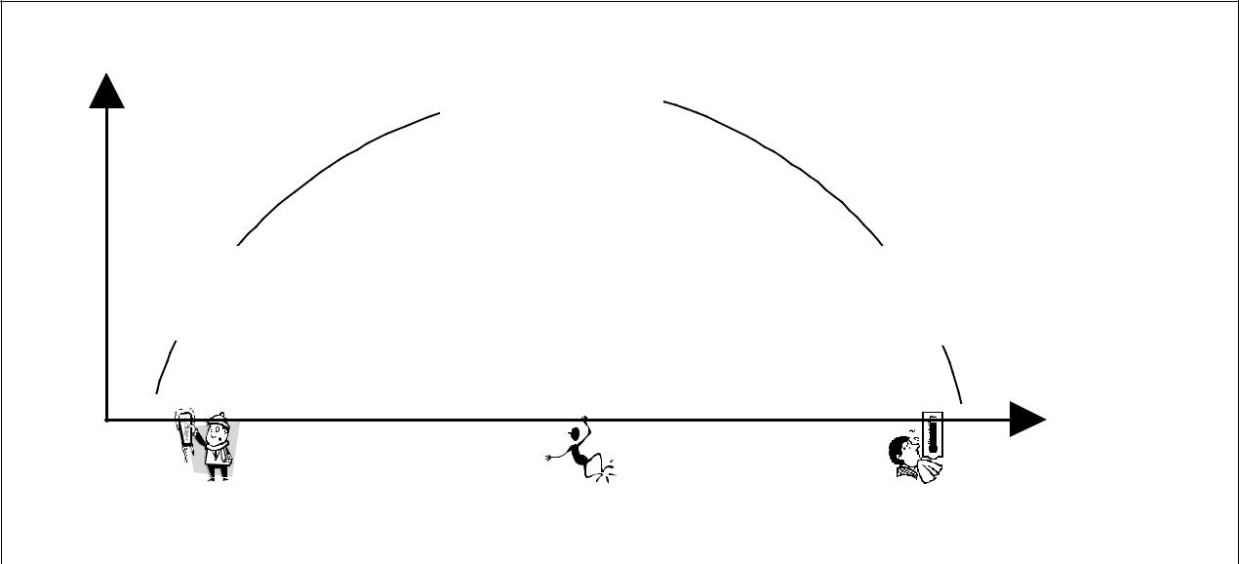

Performance
Good

Performance

Poor Poor
Performance Performance

Temperature /

Climate

Cold / wet Warm / dry Hot / humid

Figure 19 The relationship between climate, temperature and performance.

4.4 Engineers cannot be expected to maintain the rigorous standards expected in their profession in all environmental conditions. JAR 145 Acceptable Means of Compliance (AMC) 145.25(c) requires that environmental conditions be adequate for work to be carried out, stating:

“The working environment for line maintenance should be such that the particular maintenance or inspection task can be carried out without undue distraction. It therefore follows that where the working environment deteriorates to an unacceptable level in respect of temperature, moisture, hail, ice, snow, wind, light, dust/other airborne contamination, the particular maintenance or inspection tasks should be suspended until satisfactory conditions are re-established”

4.5 Unfortunately, in reality, pressure to turn aircraft round rapidly means that some maintenance tasks are not put off until the conditions are more conducive to work.

There was an instance in Scotland, where work on an aircraft was only suspended when it became so cold that the lubricants being used actually froze.

4.6 Environmental conditions can affect physical performance. For example, cold conditions make numb fingers, reducing the engineer’s ability to carry out fiddly repairs, and working in strong winds can be distracting, especially if having to work at height (e.g. on staging). Extreme environmental conditions may also be fatiguing, both physically and mentally.

4.7 There are no simple solutions to the effects of temperature and climate on the engineer. For example, an aircraft being turned around on the apron cannot usually be moved into the hangar so that the engineer avoids the worst of the weather. In the cold, gloves can be worn, but obviously the gloves themselves may interfere with fine motor skills. In the direct heat of the sun or driving rain, it is usually impossible to set up a temporary shelter when working outside.

- MOTION AND VIBRATION

5.1 Aircraft maintenance engineers often make use of staging and mobile access platforms to reach various parts of an aircraft. As these get higher, they tend to become less stable. For example when working at height on a scissors platform or ‘cherry picker’, applying force to a bolt being fixed to the aircraft may cause the platform to move away from the aircraft. The extent to which this occurs does not just depend on the height of the platform, but its design and serviceability. Any sensation of unsteadiness may distract an engineer, as he may concentrate more on keeping his balance than the task. Furthermore, it is vitally important that engineers use mobile access platforms properly in order to avoid serious injury.

5.2 Vibration in aircraft maintenance engineering is usually associated with the use of rotating or percussive tools and ancillary equipment, such as generators. Low frequency noise, such as that associated with aircraft engines, can also cause vibration. Vibration between 0.5 Hz to 20 Hz is most problematic, as the human body absorbs most of the vibratory energy in this range. The range between 50-150 Hz is most troublesome for the hand and is associated with Vibratory-induced White Finger Syndrome (VWF). Pneumatic tools can produce troublesome vibrations in this range and frequent use can lead to reduced local blood flow and pain associated with VWF. Vibration can be annoying, possibly disrupting an engineer’s concentration.

Further Reading:

- DeHart, R.L. (1991) Physical Stressors In The Workplace. In: Proceedings of the Fifth Meeting on Human Factors Issues in Aircraft Maintenance and Inspection. Available from http://hfskyway.faa.gov

- CONFINED SPACES

Chapter 2, Section 5 highlighted the possibility of claustrophobia being a problem in aircraft maintenance engineering. Working in any confined space, especially with limited means of entry or exit (e.g. fuel tanks) needs to be managed carefully. As noted previously, engineers should ideally work with a colleague who would assist their ingress into and egress out of the confined space. Good illumination and ventilation within the confined space will reduce any feelings of discomfort. In addition, appropriate safety equipment, such as breathing apparatus or lines must be used when required.

- WORKING ENVIRONMENT

7.1 Various factors that impinge upon the engineer’s physical working environment have been highlighted in this chapter. Apart from those already discussed, other physical influences include:

- workplace layout and the cleanliness and general tidiness of the workplace (e.g. storage facilities for tools, manuals and information, a means of checking that all tools have been retrieved from the aircraft, etc.);

- the proper provision and use of safety equipment and signage (such as non-slip surfaces, safety harnesses, etc.);

- the storage and use of toxic chemical and fluids (as distinct from fumes) (e.g. avoiding confusion between similar looking canisters and containers by clear labelling or storage in different locations, etc.).

Please refer to Photograph F in Appendix A.

7.2 To some extent, some or all of the factors associated with the engineer’s workplace may affect his ability to work safely and efficiently. JAR 145.25(c) - Facility Requirements states:

“The working environment must be appropriate for the task carried out and in particular special requirements observed. Unless otherwise dictated by the particular task environment, the working environment must be such that the effectiveness of personnel is not impaired.”

7.4 The working environment comprises the physical environment encapsulated in this chapter, the social environment described in Chapter 3 and the tasks that need to be carried out (examined in the next chapter). This is shown in Figure 20. Each of these three components of the working environment interact, for example:

- engineers are trained to perform various tasks;

- successful task execution requires a suitable physical environment;

- an unsuitable or unpleasant physical environment is likely to be de-motivating.
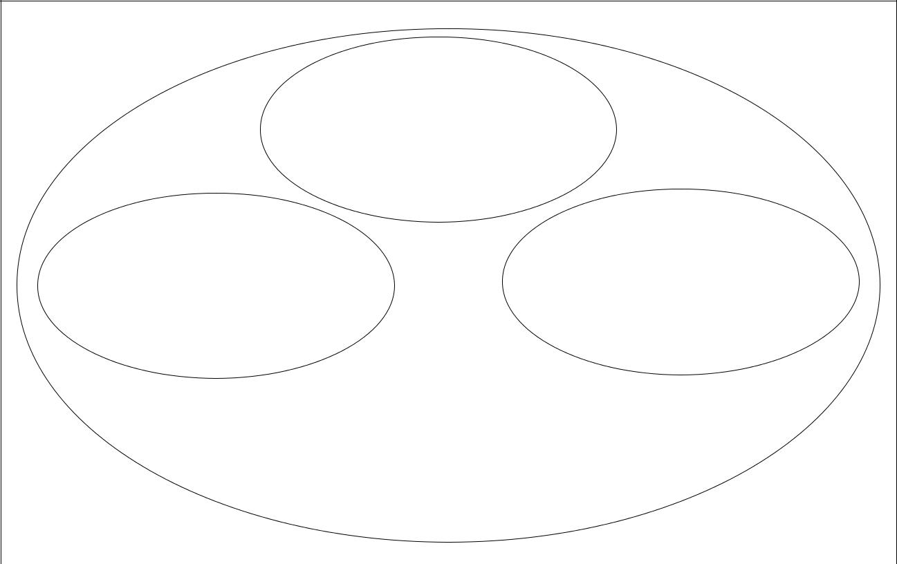

Social

Environment

(individuali i l andd teamam
responsibility,si ilit , motivation,i
culture, management,)

Physicall Environmentt Tasks

(noise,oise, illumination,iatio, fumes,es, (physicall work,, repetitivetiti e
climate, temperature,pe t, motion,, tasks, etc.)
confined spaces, workplace
layout,t, cleanliness,li, etc..)

Working Environment

Figure 20 Components of the ‘working environment’

7.5 Aircraft maintenance engineering requires all three components of the working environment to be managed carefully in order to achieve a safe and efficient system

7.6 It is important to recognise that engineers are typically highly professional and pragmatic in their outlook, and generally attempt to do the best work possible regardless of their working environment. Good maintenance organisations do their best to support this dedication by providing the necessary conditions for safe and efficient work.

Chapter 9.6 TASKS

As a self starter, training is obtained mainly on-the-job, whereas an approved course is largely classroom-based with a condensed on-the-job element. Given the varied nature of the maintenance tasks in aircraft maintenance, few engineers are ‘jacks of all trades’. Most engineers opt to specialise in the tasks they carry out, either as an Airframe and Powerplant specialist (known as A&C in UK), or as an Electrical and Avionics specialist.

When working within an aircraft maintenance organisation, an engineer will also be sent on ‘type courses’. These courses provide the engineer with requisite skills and knowledge to carry out tasks on specific aircraft, engines or aircraft systems.

The rest of this chapter examines the nature of the tasks that aircraft maintenance engineers carry out, looking at the physical work, repetitive tasks, visual inspection and the complex systems that they work on.

- PHYSICAL WORK

1.1 Planning

1.1.1 Blindly starting a task without planning how best to do it is almost certainly the best way to invite problems. Before commencing a task, an individual engineer, engineering team or planner should ask themselves a number of questions. These may include:

- Do I/we know exactly what the task is that has to be done?

- Are the resources available to do it effectively (safely, accurately and within the time permitted)? Where resources include:

  - personnel;

  - equipment/spares;

  - documentation, information and guidance;

  - facilities such as hangar space, lighting, etc.

- Do I/we have the skills and proficiency necessary to complete the task?

Please refer to Photograph G in Appendix A.

1.1.2 Information about specific tasks should be detailed on job cards or task sheets. These will indicate the task (e.g. checks or inspection, repair, replacement, overhaul) and often further details to aid the engineer (such as maintenance manual references, part numbers, etc.).

If the engineer is in any doubt what needs to be done, written guidance material is the best resource. Colleagues may unintentionally give incorrect or imprecise direction (the exception to this is discussing problems that arise that are not covered in the guidance material).

1.1.3 It is generally the shift supervisor’s job to ensure that the resources are available for his staff to carry out their tasks. As noted in Chapter 3, Section 2 (‘Time Pressure and Deadlines’), it is likely that, within a shift or a team, various sub-tasks are allocated to individuals by the supervisor. Alternatively, he may encourage a team to take ownership of the tasks that need to be completed, giving them the discretion to manage a package of work (as noted in Chapter 3, Section 6 (‘Team Working’). Exactly ‘who does what’ is likely to be based on factors such as individuals’ specialisation (i.e. A&C or avionics) and their experience with the task.

1.1.4 Although management have a responsibility to ensure that their engineers have suitable training, at the end of the day, it is up to the individual engineer to decide whether he has the necessary skills and has the proficiency and experience to do what he has been asked to do. He should not be afraid to voice any misgivings, although it is recognised that peer and management pressure may make this difficult.

1.2 Physical Tasks

1.2.1 Aircraft maintenance engineering is a relatively active occupation. Regardless of the job being done, most tasks tend to have elements of fine motor control, requiring precision, as well as activities requiring strength and gross manipulation.

1.2.2 From a biomechanical perspective, the human body is a series of physical links (bones) connected at certain points (joints) that allow various movements. Muscles provide the motive force for all movements, both fine and gross. This is known as the musculoskeletal system. The force that can be applied in any given posture is dependent on the strength available from muscles and the mechanical advantage provided by the relative positions of the load, muscle connections, and joints.

As an engineer gets older, the musculoskeletal system stiffens and muscles become weaker. Injuries become more likely and take longer to heal. Staying in shape will minimize the effects of ageing, but they still occur.

1.2.3 It is important that maintenance tasks on aircraft are within the physical limitations of aircraft maintenance engineers. Boeing use a computerised tool¹, based on human performance data (body sizes, strengths, leverages, pivots, etc.), to ensure that modern aircraft are designed such that the majority of maintenance engineers will be able to access aircraft equipment, apply the necessary strength to loosen or tighten objects, etc. (i.e. designed for ease of maintainability).

1.2.4 Clearly we are all different in terms of physical stature and strength and as a consequence, our physical limitations vary. Attempting to lift a heavy object which is beyond our physical capabilities is likely to lead to injury. The use of tools generally make tasks easier, and in some situations, may make a task achievable that was hitherto outside our physical powers (e.g. lifting an aircraft panel with the aid of a hoist).

1.2.5 As noted in Chapter 4, Section 5 (‘Fatigue’), physical work over a period of time will result in fatigue. This is normally not a problem if there is adequate rest and recovery time between work periods. It can, however, become a problem if the body is not allowed to recover, possibly leading to illness or injuries. Hence, engineers should try to take their allocated breaks.

Missing a break in an effort to get a job done within a certain time frame can be counterproductive, as fatigue diminishes motor skills, perception, awareness and standards. As a consequence, work may slow and mistakes may occur that need to be rectified.

1.2.6 As discussed at some length in Chapter 4, Section 1 (‘Day-to-Day Fitness and Health’), it is very important that engineers should try to ensure that their physical fitness is good enough for the type of tasks which they normally do.

- REPETITIVE TASKS

2.1 Repetitive tasks can be tedious and reduce arousal (i.e. be boring). Most of the human factors research associated with repetitive tasks has been carried out in manufacturing environments where workers carry out the same action many times a minute. This does not generally apply to maintenance engineering.

Repetitive tasks in aircraft maintenance engineering typically refer to tasks that are performed several times during a shift, or a number of times during a short time period, e.g. in the course of a week. An example of this would be the checking life jackets on an aircraft during daily inspections.

2.2 Some engineers may specialise in a certain aspect of maintenance, such as engines.

As a result, they may possibly carry out the same or similar tasks several times a day.

2.3 The main danger with repetitive tasks is that engineers may become so practised at such tasks that they may cease to consult the maintenance manual, or to use job cards. Thus, if something about a task is changed, the engineer may not be aware of the change. Complacency is also a danger, whereby an engineer may skip steps or fail to give due attention to steps in a procedure, especially if it is to check something which is rarely found to be wrong, damaged or out of tolerance. This applies particularly to visual inspection, which is covered in greater detail in the next section.

In the Aloha accident report, the NTSB raised the problem of repetitive tasks:

“The concern was expressed about what kinds of characteristics are appropriate to consider when selecting persons to perform an obviously tedious, repetitive task such as a protracted NDI inspection. Inspectors normally come up through the seniority ranks. If they have the desire, knowledge and skills, they bid on the position and are selected for the inspector job on that basis. However, to ask a technically knowledgeable person to perform an obviously tedious and exceedingly boring task, rather than to have him supervise the quality of the task, may not be an appropriate use of personnel…”

2.4 Making assumptions along the lines of ‘Oh I’ve done that job dozens of times!’ can occur even if a task has not been undertaken for some time. It is always advisable to be wary of changes to procedures or parts, remembering that ‘familiarity breeds contempt’.

- VISUAL INSPECTION

3.1 Visual inspection is one of the primary methods employed during maintenance to ensure the aircraft remains in an airworthy condition.

Visual inspection can be described as the process of using the eye, alone or in conjunction with various aids to examine and evaluate the condition of systems or components of an aircraft.

3.2 Aircraft maintenance engineers may use magnifiers and borescopes to enhance their visual capabilities. The engineer may accompany his visual inspection by examining the element using his other senses (touch, hearing, smell, etc.). He may also manipulate the element being inspected to make further judgements about its condition. For instance, he might feel a surface for unevenness, or push against it to look for any unanticipated movement.

3.3 As highlighted in Chapter 2, Section 2 (“Vision and the Aircraft Maintenance Engineer”), good eyesight is of prime importance in visual inspection, and it was noted that the UK CAA have provided some guidance on eyesight in AWN47. Amongst other things, this calls for glasses or contact lenses to be used where prescribed and regular eyesight checks to be made.

3.4 Visual inspection is often the principal method used to identify degradation or defect in systems or components of aircraft. Although the engineer’s vision is important, he also has to make judgments about what he sees. To do this, he brings to bear training, experience and common sense. Thus, reliable visual inspection requires that the engineer first sees the defect and then actually recognises that it is a defect. Of course, experience comes with practice, but telltale signs to look for can be passed on by more experienced colleagues.

3.5 Please refer to Photograph H in Appendix A.

Information such as technical bulletins are important as they prime the inspector of known and potential defects and he should keep abreast of these. For example, blue staining on an aircraft fuselage may be considered insignificant at first sight, but information from a Technical Bulletin of ‘blue ice’ and external toilet leaks may make the engineer suspicious of a more serious problem

3.6 There are various steps that an engineer can take to help him carry out a reliable visual inspection. The engineer should:

- ensure that he understands the area, component or system he has been asked to inspect (e.g. as specified on the work card);

- locate the corresponding area, component or system on the aircraft itself;

- make sure the environment is conducive to the visual inspection task (considering factors described in Chapter 5 - “Physical Environment”, such as lighting, access, etc.);

- conduct a systematic visual search, moving his eyes carefully in a set pattern so that all parts are inspected;

- examine thoroughly any potential degradation or defect that is seen and decide whether it constitutes a problem;

- record any problem that is found and continue the search a few steps prior to where he left off.

3.7 Visual inspection requires a considerable amount of concentration. Long spells of continuous inspection can be tedious and result in low arousal. An engineer’s low arousal or lack of motivation can contribute to a failure to spot a potential problem or a failure in recognising a defect during visual inspection. The effects are potentially worse when an inspector has a very low expectation of finding a defect, e.g. on a new aircraft.

3.8 Engineers may find it beneficial to take short breaks between discrete visual inspection tasks, such as at a particular system component, frame, lap joint, etc. This is much better than pausing midway through an inspection.

The Aloha accident highlights what can happen when visual inspection is poor. The accident report included two findings that suggest visual inspection was one of the main contributors to the accident:

- “There are human factors issues associated with visual and non-destructive inspection which can degrade inspector performance to the extent that theoretically detectable damage is overlooked.”

- “Aloha Airlines management failed to recognise the human performance factors of inspection and to fully motivate and focus their inspector force toward the critical nature of lap joint inspection, corrosion control and crack detection…..”

3.9 Finally, non-destructive inspection (NDI) includes an element of visual inspection, but usually permits detection of defects below visual thresholds. Various specialist tools are used for this purpose, such as the use of eddy currents and fluorescent penetrant inspection (FPI).

- COMPLEX SYSTEMS

4.1 All large modern aircraft can be described as complex systems. Within these aircraft, there are a myriad of separate systems, many of which themselves may be considered complex, e.g. flying controls, landing gear, air conditioning, flight management computers. Table 4 gives an example of the breadth of complexity in aircraft systems.

Any complex system can be thought of as having a wide variety of inputs. The system

typically performs complex modifications on these inputs or the inputs trigger complex

responses. There may be a single output, or many distributed outputs from the system.

4.2 The purpose, composition and function of a simple system is usually easily understood by an aircraft maintenance engineer. In other words, the system is transparent to him. Fault finding and diagnosis should be relatively simple with such systems (although appropriate manuals etc. should be referred to where necessary).

Table 4 | Example of increasing complexity - the aileron system
TYPE OF |  | NATURE OF SYSTEM
AILERON |  | NATURE OF SYSTEM
Simple aileron |  | Direct connection from control column to control surface; direct
 |  | movement.
Servo tab |  | Direct connection from control column to servo tab; aerodynamic
aileron |  | movement of surface.
Powered |  | Connection from control column to servo valve via input; hydraulic
aileron |  | movement of surface; feedback mechanism; position indication.
Powered |  | As above but with interface to spoiler input system to provide additional
aileron / roll |  | roll capability.
spoiler
Fly-by-wire |  | No connection from control column to surface. Electrical command
aileron system |  | signal to electro-hydraulic servo valve on actuator; signal modified and
 |  | limited by intermediate influence of flight control computer.

4.3 With a complex system, it should still be clear to an aircraft maintenance engineer what the system’s purpose is. However, its composition and function may be harder to conceptualise - it is opaque to the engineer.

4.4 To maintain such complex systems, it is likely that the engineer will need to have carried out some form of system-specific training which would have furnished him with an understanding of how it works (and how it can fail) and what it is made up of (and how components can fail). It is important that the engineer understands enough about the overall functioning of a large, complex aircraft, but not so much that he is overwhelmed by its complexity. Thus, system-specific training must achieve the correct balance between detailed system knowledge and analytical troubleshooting skills.
the letter, since deviations from procedures may have implication on other parts of the system of which the engineer may be unaware.

When working with complex systems, it is important that the aircraft maintenance engineer makes reference to appropriate guidance material. This typically breaks down the system conceptually or physically, making it easier to understand and work on.

Chapter 9.7 COMMUNICATION

Good communication is important in every industry. In aircraft maintenance engineering, it is vital. Communication, or more often a breakdown in communication, is often cited as a contributor to aviation incidents and accidents. It is for this very reason that it has its own section in the JAR66 Module 9 for Human Factors. This chapter examines the various aspects of communication that affect the aircraft maintenance engineer.

Communication is defined in the Penguin Dictionary of Psychology as:

“The transmission of something from one location to another. The ‘thing’ that is transmitted may be a message, a signal, a meaning, etc. In order to have communication both the transmitter and the receiver must share a common code, so that the meaning or information contained in the message may be interpreted without error”.

Source: Reber, A.S., 1995¹

- WITHIN AND BETWEEN TEAMS

As noted in previous chapters, aircraft maintenance engineers often work as teams. Individuals within teams exchange information and need to receive instructions, guidance, etc. Moreover, one team will have to pass on tasks to another team at shift handover. An engineer needs a good understanding of the various processes of communication, as without this, it is impossible to appreciate how communication can go wrong.

1.1 Modes of Communication

1.1.1 We are communicating almost constantly, whether consciously or otherwise. An aircraft maintenance engineer might regularly communicate:

- information;

- ideas;

- feelings;

- attitudes and beliefs

1.1.2 As the sender of a message, he will typically expect some kind of response from the person he is communicating with (the recipient), which could range from a simple acknowledgement that his message has been received (and hopefully understood), to a considered and detailed reply. The response constitutes feedback.

1.1.3 As can be seen in the above definition, communication can be:

- verbal/spoken - e.g. a single word, a phrase or sentence, a grunt;

- written/textual - e.g. printed words and/or numbers on paper or on a screen, hand written notes;

- non-verbal -

  - graphic - e.g. pictures, diagrams, hand drawn sketches, indications on a cockpit instrument;

  - symbolic - e.g. ‘thumbs up’, wave of the hand, nod of the head;

  - body language - e.g. facial expressions, touch such as a pat on the back, posture.

1.2 Verbal and Written Communication

1.2.1 Generally speaking, verbal and written communication are purposeful. For a spoken or written message to be understood, the sender has to make sure that the receiver:

- is using the same channel of communication;

- recognises and understands his language;

- is able to make sense of the message’s meaning;

1.2.2 The channel of communication is the medium used to convey the message. For spoken communication, this might be face-to-face, or via the telephone. Written messages might be notes, memos, documents or e-mails.

1.2.3 In the UK it is expected that aircraft maintenance engineers will communicate in English. However, it is also vital that the message coding used by the sender is appreciated by the recipient so that he can decode the message accurately. This means that engineers must have a similar knowledge of technical language, jargon and acronyms.

1.2.4 Assuming the channel and language used are compatible, to extract meaning, the engineer has to understand the content of the message. This means that it has to be clear and unambiguous. The message must also be appropriate to the context of the workplace and preferably be compatible with the receiver’s expectations. Where any ambiguity exists, the engineer must seek clarification.

1.3 Non-verbal Communication

1.3.1 Non-verbal communication can accompany verbal communication, such as a smile during a face-to-face chat. It can also occur independently, for instance a colleague may pass on his ideas by using a sketch rather than the use of words. It can also be used when verbal communication is impossible, such as a nod of the head in a noisy environment.

1.3.2 Non-verbal communication is also the predominant manner by which systems communicate their status. For instance, most displays in the aircraft cockpit present their information graphically.

1.3.3 Body language can be very subtle, but often quite powerful. For example, the message “No” accompanied by a smile will be interpreted quite differently from the same word said whilst the sender scowls.

1.4 Communication Within Teams

1.4.1 Individual aircraft maintenance engineers need to communicate:

- before starting a task - to find out what to do;

- during a task - to discuss work in progress, ask colleagues questions, confirm actions or intentions, or to ensure that others are informed of the maintenance state at any particular time;

- at the end of a task - to report its completion and highlight any problems.

1.4.2 Spoken communication makes up a large proportion of day-to-day communication within teams in aircraft maintenance. It relies both on clear transmission of the message (i.e. not mumbled or obscured by background noise) and the ability of the recipient of the message to hear it (i.e. active listening followed by accurate interpretation of the message). Good communication within a team helps to maintain group cohesion.

Spoken messages provide considerable flexibility and informality to express work-related matters when necessary. The key to such communication is to use words effectively and obtain feedback to make sure your message has been heard and understood.

1.4.3 It is much less common for individuals within teams to use written communication. They would however be expected to obtain pertinent written information communicated by service bulletins and work cards and to complete documentation associated with a task.

1.5 Communication Between Teams

1.5.1 Communication between teams is critical in aircraft maintenance engineering. It is the means by which one team passes on tasks to another team. This usually occurs at shift handover. The information conveyed will include:

- tasks that have been completed;

- tasks in progress, their status, any problems encountered, etc.;

- tasks to be carried out;

- general company and technical information.

1.5.2 Communication between teams will involve passing on written reports of tasks from one shift supervisor to another. Ideally, this should be backed up by spoken details passed between supervisors and, where appropriate, individual engineers. This means that, wherever necessary, outgoing engineers personally brief their incoming colleagues. The written reports (maintenance cards, procedures, work orders, logs, etc.) and warning flags / placards provide a record of work completed and work yet to be completed - in other words, they provide traceability (see Section 2 below). Furthermore, information communicated at shift handover ensures good continuity. It is important that handovers are not rushed, so as to minimise omissions.

1.6 Communication Problems

1.6.1 There are two main ways in which communication can cause problems. These are lack of communication and poor communication. The former is characterised by the engineer who forgets to pass on pertinent information to a colleague, or when a written message is mislaid. The latter is typified by the engineer who does not make it clear what he needs to know and consequently receives inappropriate information, or a written report in barely legible handwriting. Both problems can lead to subsequent human error.

1.6.2 Communication also goes wrong when one of the parties involved makes some kind of assumption. The sender of a message may assume that the receiver understands the terms he has used. The receiver of a message may assume that the message means one thing when in fact he has misinterpreted it. Assumptions may be based on context and expectations, which have already been mentioned in this chapter. Problems with assumptions can be minimised if messages are unambiguous and proper feedback is given.

Basic rules of thumb to help aircraft maintenance engineers minimise poor communication are:

- think about what you want to say before speaking or writing;

- speak or write clearly;

- listen or read carefully;

- seek clarification wherever necessary.

Further Reading:

- Maddox, M.E. (Ed.) (1998) Human Factors Guide for Aviation Maintenance 3.0. Washington DC: Federal Aviation Administration/Office of Aviation Medicine - Chapter 13. Available from http://hfskyway.faa.gov

- Sian, B. and Robertson, M. (1998) Maintenance Resource Management Handbook. Available from http://hfskyway.faa.gov

- WORK LOGGING AND RECORDING

2.1 This is one of the most critical aspects of communication within aviation maintenance, since inadequate logging or recording of work has been cited as a contributor to several incidents.

The exact manner in which work should be logged tends to be prescribed by company procedures. It is usually recorded in written form. However, there is no logical reason why symbols and pictures should not also be used to record work or problems, especially when used for handovers. There are many cases where it may be clearer to draw a diagram rather than to try to explain something in words (i.e. ‘a picture is worth a thousand words’).

“In relation to work carried out on an aircraft, it is the duty of all persons to whom this Notice applies to ensure that an adequate record of the work carried out is maintained. This is particularly important where such work carries on beyond a working period or shift, or is handed over from one person to another. The work accomplished, particularly if only disassembly or disturbance of components or aircraft systems, should be recorded as the work progresses or prior to undertaking a disassociated task. In any event, records should be completed no later than the end of the work period or shift of the individual undertaking the work. Such records should include ‘open’ entries to reflect the remaining actions necessary to restore the aircraft to a serviceable condition prior to release. In the case of complex tasks which are undertaken frequently, consideration should be given to the use of pre-planned stage sheets to assist in the control, management and recording of these tasks. Where such sheets are used, care must be taken to ensure that they accurately reflect the current requirements and recommendations of the manufacturer and that all key stages, inspections, or replacements are recorded.”

2.5 New technology is likely to help engineers to record work more easily and effectively in the future. ICAO Digest No.12: “Human Factors in Aircraft Maintenance and Inspection”², refers to hand-held computers and an Integrated Maintenance Information System (IMIS). It points out that these devices are likely to encourage the prompt and accurate recording of maintenance tasks.

2.6 Modern technology is also being implemented to improve the transfer of information in maintenance manuals to worksheets and workcards. These help to communicate pertinent information to engineers in an accessible and useable format. A contributory factor in the B737 double engine oil loss incident was that the information which should have prompted the engineer to carry out a post-inspection idle engine run to check for leaks was in the maintenance manual but not carried over to the task cards.

- KEEPING UP-TO-DATE, CURRENCY

3.1 As discussed in Chapter 6, aircraft maintenance engineers undertake an approved course to obtain the knowledge and basic skills to enter the profession. This training is followed by instruction in more specific areas, such as maintenance of individual aircraft and specific systems (as discussed in Chapter 6, Section 4 on “Complex Systems”). However, the aviation industry is dynamic: operators change their aircraft, new aircraft types and variants are introduced, new aircraft maintenance practices are introduced. As a consequence, the engineer needs to keep his knowledge and skills up-to-date.

3.2 To maintain his currency, he must keep abreast of pertinent information relating to:

- new aircraft types or variants;

- new technologies and new aircraft systems;

- new tools and maintenance practices;

- modifications to current aircraft and systems he works on;

- revised maintenance procedures and practices.

Engineers are likely to keep up-to-date by:

- undertaking update courses;

- reading briefing material, memos and bulletins;

- studying maintenance manual amendments

3.3 Responsibility for maintaining currency lies with both the individual engineer and the maintenance organisation for which he works. The engineer should make it his business to keep up-to-date with changes in his profession (remembering that making assumptions can be dangerous). The organisation should provide the appropriate training and allow their staff time to undertake the training before working on a new aircraft type or variant. It should also make written information easily accessible to engineers and encourage them to read it. It is, of course, vital that those producing the information make it easy for engineers to understand (i.e. avoid ambiguity)

3.4 From a human factors point of view, small changes to the technology or procedures concerning existing aircraft carry potentially the greatest risk. These do not usually warrant formal training and may merely be minor changes to the maintenance manual. Although there should be mechanisms in place to record all such changes, this presumes that the engineer will consult the updates. It is part of the engineer’s individual responsibility to maintain his currency.

- DISSEMINATION OF INFORMATION

4.1 As highlighted in the previous section, both the individual engineer and the organisation in which he works have a shared responsibility to keep abreast of new information. Good dissemination of information within an organisation forms part of
its safety culture Typically, the maintenance organisation will be the sender and the individual engineer will be the recipient.

4.2 “Planning”, that an aircraft maintenance engineer or team of engineers need to plan the way work will be performed. Part of this process should be checking that all information relating to the task has been gathered and understood. This includes checking to see if there is any information highlighting a change associated with the task (e.g. the way something should be done, the tools to be used, the components or parts involved)

It is imperative that engineers working remotely from the engineering base (e.g. on the line) familiarise themselves with new information (on notice boards, in maintenance manuals, etc.) on a regular basis.

Chapter 9.8 HUMAN ERROR

It has long been acknowledged that human performance is at times imperfect. Nearly two thousand years ago, the Roman philosopher Cicero cautioned “It is the nature of man to err”. It is an unequivocal fact that whenever men and women are involved in an activity, human error will occur at some point.

In his book “Human Error”, Professor James Reason defines error as follows:

“Error will be taken as a generic term to encompass all those occasions in which a planned sequence of mental or physical activities fails to achieve its intended outcome, and when these failures cannot be attributed to the intervention of some chance agency”.

- ERROR MODELS AND THEORIES

To appreciate the types of error that it is possible to make, researchers have looked at human error in a number of ways and proposed various models and theories. These attempt to capture the nature of the error and its characteristics. To illustrate this, the following models and theories will be briefly highlighted:

- design- versus operator-induced errors;

- variable versus constant errors;

- reversible versus irreversible errors;

- slips, lapses and mistakes;

- skill-, rule- and knowledge-based behaviours and associated errors;

- the ‘Swiss Cheese Model’.

1.1 Design-Versus Operator-Induced Errors

1.1.1 In aviation, emphasis is often placed upon the error(s) of the front line operators, who may include flight crew, air traffic controllers and aircraft maintenance engineers.

1.1.2 However, errors may have been made before an aircraft ever leaves the ground by aircraft designers. This may mean that, even if an aircraft is maintained and flown as it is designed to be, a flaw in its original design may lead to operational safety being compromised. Alternatively, flawed procedures put in place by airline, maintenance organisation or air traffic control management may also lead to operational problems.

1.1.3 It is common to find when investigating an incident or accident that more than one error has been made and often by more than one person. It may be that, only when a certain combination of errors arises and error ‘defences’ breached (see the ‘Swiss Cheese Model’) will safety be compromise

1.2 Variable Versus Constant Errors
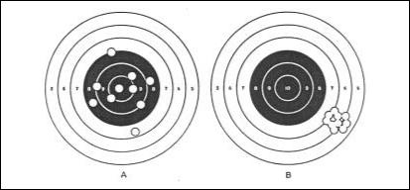

Figure 22 Variable versus Constant Errors.

Target patterns of 10 shots fired by two riflemen. Rifleman A’s pattern exhibits no constant error, but large variable errors; rifleman B’s pattern exhibit’s a large constant error but small variable errors. The latter would, potentially, be easier to predict and to correct

1.3 Reversible Versus Irreversible Errors

1.3.1 Another way of categorising errors is to determine whether they are reversible or irreversible. The former can be recovered from, whereas the latter typically cannot be. For example, if a pilot miscalculates the fuel he should carry, he may have to divert to a closer airfield, but if he accidentally dumps his fuel, he may not have many options open to him.

1.3.2 A well designed system or procedure should mean that errors made by aircraft maintenance engineers are reversible. Thus, if an engineer installs a part incorrectly, it should be spotted and corrected before the aircraft is released back to service by supervisory procedures in place.
1.4 Slips, Lapses and Mistakes

1.4.1 Reason highlights the notion of ‘intention’ when considering the nature of error, asking the questions:

- Were the actions directed by some prior intention?

- Did the actions proceed as planned?

- Did they achieve their desired end?

1.4.2 Reason then suggests an error classification based upon the answers to these questions as shown in Figure 23.
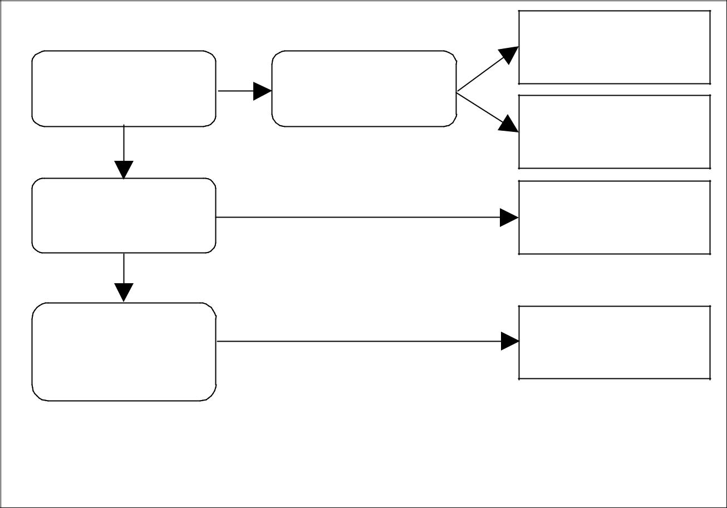

 |  | NO | Involuntary or non-
 |  | NO | intentional action
Was there a prior | NO | Was there intention | intentional action
intention to act? |  | in the action? | Spontaneous or
 |  | YES | Spontaneous or
YES |  | YES | subsidiary action
Did the actions |  | NO | Unintentional action
proceed as planned? |  |  | - slip or lapse
YES
Did the actions |  | NO | Intentional but
achieve the desired |  |  | mistaken action
end?

 YES

SUCCESSFUL ACTION

Figure 23 Error types based on intention. Source: Reason, 1990

1.4.3 The most well-known of these are slips, lapses and mistakes.

Slips can be thought of as actions not carried out as intended or planned, e.g. ‘transposing digits when copying out numbers, or misordering steps in a procedure.

Lapses are missed actions and omissions, i.e. when somebody has failed to do something due to lapses of memory and/or attention or because they have forgotten something, e.g. forgetting to replace an engine cowling.

Mistakes are a specific type of error brought about by a faulty plan/intention, i.e. somebody did something believing it to be correct when it was, in fact, wrong, e.g. an error of judgement such as mis-selection of bolts when fitting an aircraft windscreen.

Violations sometimes appear to be human errors, but they differ from slips, lapses and mistakes because they are deliberate ‘illegal’ actions, i.e. somebody did something knowing it to be against the rules (e.g. deliberately failing to follow proper procedures). Aircraft maintenance engineers may consider that a violation is well-intentioned, i.e. ‘cutting corners’ to get a job done on time. However, procedures must be followed appropriately to help safeguard safety.

1.5 Skill-, Rule- and Knowledge-Based Behaviours and Associated Errors

1.5.1 The behaviour of aircraft maintenance engineers can be broken down into three

distinct categories: skill-based, rule-based and knowledge-based behaviour.

Green et al define these:

“Skill-based behaviours are those that rely on stored routines or motor programmes that have been learned with practice and may be executed without conscious thought.

Rule-based behaviours are those for which a routine or procedure has been learned. The components of a rule-based behaviour may comprise a set of discrete skills.

Knowledge-based behaviours are those for which no procedure has been established. These require the [aircraft maintenance engineer] to evaluate information, and then use his knowledge and experience to formulate a plan for dealing with the situation.”

1.5.2 Each of these behaviour types have specific errors associated with them.

1.5.3 Examples of skill-based errors are action slips, environmental capture and reversion. Action slips as the name implies are the same as slips, i.e. an action not carried out as intended. The example given in Figure 24 may consist of an engineer realising he needs a certain wrench to complete a job but, because he is distracted by a colleague, picks up another set to the wrong torque and fails to notice that he has tightened the bolts incorrectly.

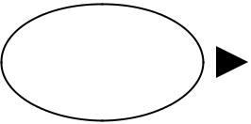 |  |  | Aircraft |  |  | Aircraft
Correct |  |  | maintenance |  | Wrong skill | maintenance
 |  |  |  |  |  |  |  |  |  | ERROR
decision |  |  | engineer is |  | applied | engineer fails |  |  |  | ERROR
 |  |  | distracted |  |  | to monitor
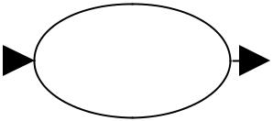


Figure 24 Example of an Action Slip

1.5.6 Rule-based behaviour is generally fairly robust and this is why the use of procedures and rules is emphasised in aircraft maintenance. However, errors here are related to the use of the wrong rule or procedure. For example, an engineer may misdiagnose a fault and thus apply the wrong procedure, thus not clearing the fault. Errors here are also sometimes due to faulty recall of procedures. For instance, not remembering the correct sequence when performing a procedure.

1.5.7 Errors at the knowledge-based performance level are related to incomplete or incorrect knowledge or interpreting the situation incorrectly. An example of this might be when an engineer attempts an unfamiliar repair task and assumes he can ‘work it out’. Once he has set out in this way, he is likely to take more notice of things that suggest he is succeeding in his repair, while ignoring evidence to the contrary (known as confirmation bias).

1.6 The ‘Swiss Cheese Model’

1.6.1 In his research, Reason has highlighted the concept of ‘defences’ against human error within an organisation, and has coined the notion of ‘defences in depth’. Examples of defences are duplicate inspections, pilot pre-flight functional checks, etc., which help prevent to ‘trap’ human errors, reducing the likelihood of negative consequences. It is when these defences are weakened and breached that human errors can result in incidents or accidents. These defences have been portrayed diagramatically, as several slices of Swiss cheese (and hence the model has become known as Professor Reason’s “Swiss cheese” model) (see Figure 25).
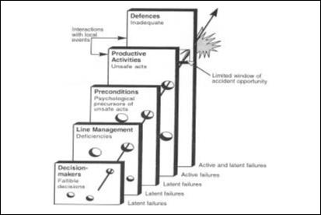

Figure 25 Reason’s Swiss Cheese Model.
1.6.2 Some failures are latent, meaning that they have been made at some point in the past and lay dormant. This may be introduced at the time an aircraft was designed or may be associated with a management decision. Errors made by front line personnel, such as aircraft maintenance engineers, are ‘active’ failures. The more holes in a system’s defences, the more likely it is that errors result in incidents or accidents, but it is only in certain circumstances, when all holes ‘line up’, that these occur. Usually, if an error has breached the engineering defenses, it reaches the flight operations defences (e.g. in flight warning) and is detected and handled at this stage. However, occasionally in aviation, an error can breach all the defenses (e.g. a pilot ignores an in-flight warning, believing it to be a false alarm) and a catastrophic situation ensues.

1.6.3 Defenses in aircraft maintenance engineering will be considered further in Section 4.

- TYPES OF ERROR IN MAINTENANCE TASKS

2.1 As aircraft maintenance engineers are human, errors in the industry are inevitable.

Any maintenance task performed on an aircraft is an opportunity for human error to be introduced. Errors in aircraft maintenance engineering tend to take two specific forms:

- an error that results in a specific aircraft problem that was not there before the maintenance task was initiated;

- an error that results in an unwanted or unsafe condition remaining undetected while performing a maintenance task designed to detect aircraft problems, i.e. something is missed.

2.3 Errors During Regular and Less Frequent Maintenance Tasks

2.3.1 A large proportion of maintenance tasks are fairly routine, such as regular, periodic checks on aircraft. Thus, engineers will use a certain set of procedures relatively frequently and, as noted in the previous section, slips and lapses can occur when carrying out procedures in the busy hangar or line environment. Chapter 6, Section 2 “Repetitive Tasks” noted that engineers will often become so accustomed to doing a regular, often repeated task, that they will dispense with written guidance altogether. It would be unrealistic and unnecessarily time consuming to expect them to constantly refer to familiar guidance material. However, errors may occur if they do not keep up-to-date with any changes that occur to these frequently used procedures. These routine tasks are also prone to complacency, environmental capture and rule-based errors.

2.3.2 When undertaking less frequently performed tasks, there is the possibility of errors of judgment. If the engineer does not familiarize or refamiliarize himself properly with what needs to be done, he may mistakenly select the wrong procedure or parts.

2.4 Violation in Aircraft Maintenance

2.4.1 It is an unfortunate fact of life that violations occur in aviation maintenance. Most stem from a genuine desire to do a good job. Seldom are they acts of vandalism or

sabotage. However. they represent a significant threat to safety as systems are designed assuming people will follow the procedures. There are four types of violations:

- Routine violations;

- Situational violations;

- Optimizing violations;

- Exceptional violations.

2.4.2 Routine violations are things which have become ‘the normal way of doing something’ within the person’s work group (e.g. a maintenance team). They can become routine for a number of reasons: engineers may believe that procedures may be over prescriptive and violate them to simplify a task (cutting corners), to save time and effort.

2.4.3 Situational violations occur due to the particular factors that exist at the time, such as time pressure, high workload, unworkable procedures, inadequate tooling, poor working conditions. These occur often when, in order to get the job done, engineers consider that a procedure cannot be followed.

2.4.4 Optimizing violations involve breaking the rules for ‘kicks’. These are often quite unrelated to the actual task. The person just uses the opportunity to satisfy a personal need.

2.4.5 Exceptional violations are typified by particular tasks or operating circumstances that make violations inevitable, no matter how well intentioned the engineer might be.

2.4.6 Time pressure and high workload increase the likelihood of all types of violations occurring. People weigh up the perceived risks against the perceived benefits, unfortunately the actual risks can be much higher.

2.5 Errors Due to Individual Practices and Habits

2.5.1 Where procedures allow some leeway, aircraft maintenance engineers often develop their own strategies or preferred way of carrying out a task. Often, a ‘good’ rule or principle is one that has been used successfully in the past. These good rules become ‘rules of thumb’ that an engineer might adopt for day-to-day use. Problems occur when the rule or principle is wrongly applied. For example, aircraft pipe couplings are normally right hand threads but applying this ‘normally good rule’ to an oxygen pipe (having a different thread) could result in damage to the pipe. Also, there can be dangers in applying rules based on previous experience if, for example, design philosophy differs

2.6 Errors Associated With Visual Inspection

There are also two particular types of error which are referred to particularly in the context of visual inspection, namely Type 1 errors and Type 2 errors. A Type 1 error occurs when a good item is incorrectly identified as faulty; a Type 2 error occurs when a faulty item is missed. Type 1 errors are not a safety concern per se, except that it means that resources are not being used most effectively, time being wasted on further investigation of items which are not genuine faults. Type 2 errors are of most concern since, if the fault (such as a crack) remains undetected, it can have serious consequences (as was the case in the Aloha accident, where cracks remained undetected).

2.7 Reason’s Study of Aviation Maintenance Engineering

2.7.1 Reason analysed the reports of 122 maintenance incidents occurring within a major airline over a 3 year period. He identified the main causes as being:

- Omissions (56%)

- Incorrect installation (30%)

- Wrong parts (8%)

- Other (6%)

2.7.2 It is likely that Reason’s findings are representative for the aircraft maintenance industry as a whole. Omissions can occur for a variety of reason, such as forgetting, deviation from a procedure (accidental or deliberate), or due to distraction. The B737² double engine oil loss incident, in which the HP rotor drive covers were not refitted is an example of omission. Incorrect installation is unsurprising, as there is usually only one way in which something can be taken apart but many possible ways in which it can be reassembled. Reason illustrates this with a simple example of a bolt and several nuts (see Figure 26), asking the questions (a) how many ways can this be

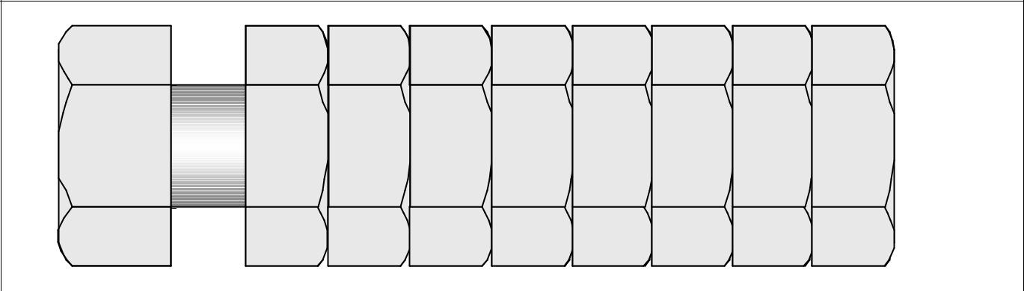

A B C D E F G H 

Figure 26 Reason’s Bolt and Nuts Example.

- IMPLICATIONS OF ERRORS (I.E. ACCIDENTS)

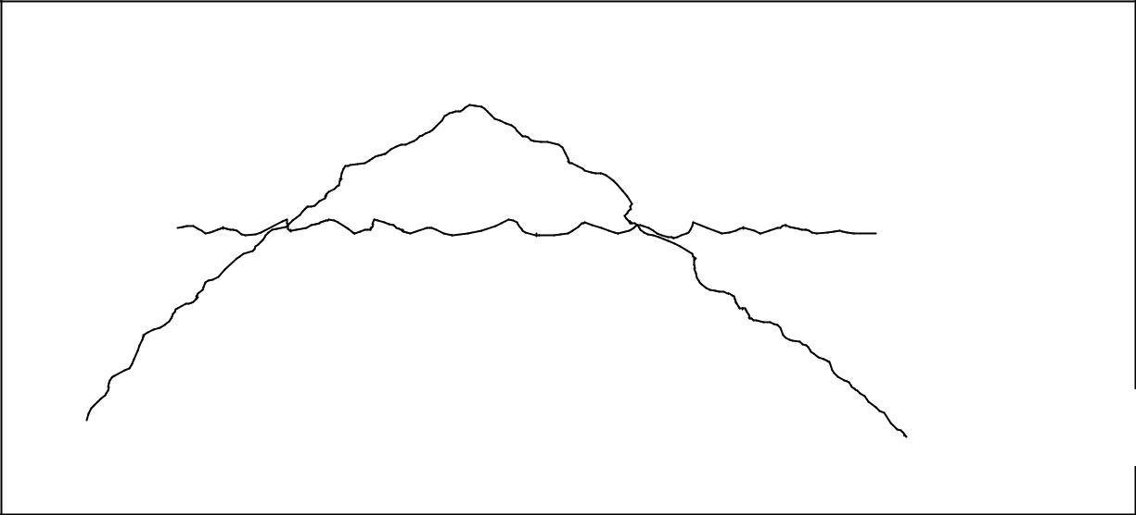
Iceberg

Accidents

Serious Incidents
Sea level

Incidents

Errors

Minor events

Figure 27 The “Iceberg Model” of Accidents

3.2 Thankfully, most errors made by aircraft maintenance engineers do not have catastrophic results. This does not mean that this might not be the result should they occur again.

3.3 Errors that do not cause accidents but still cause a problem are known as incidents. This subject was introduced at the beginning of this document in Chapter 1, Section 2 “Incidents Attributable To Human Factors / Human Error”, which gave examples of aviation incidents relating to aircraft maintenance errors. Some incidents are more high profile than others, such as errors causing significant in-flight events that, fortuitously, or because of the skills of the pilot, did not become accidents. Other incidents are more mundane and do not become serious because of defences built into the maintenance system. However, all incidents are significant to the aircraft maintenance industry, as they may warn of a potential future accident should the error occur in different circumstances. As a consequence, all maintenance incidents have to be reported to the UK Civil Aviation Authority Mandatory Occurrence Reporting Scheme (MORS). These data are used to disclose trends and, where necessary, implement action to reduce the likelihood or criticality of further errors. In the UK, the Confidential Human Factors Incident Reporting Programme (CHIRP) scheme provides an alternative reporting mechanism for individuals who want to report safety concerns and incidents confidentially.
Avoiding and Managing Errors

4.1 Whilst the aircraft maintenance engineering industry should always strive towards ensuring that errors do not occur in the first place, it will never be possible to eradicate them totally. Therefore all maintenance organisations should aim to ‘manage’ errors.

4.2 Reason refers to the two components of error management as: (i) error containment and (ii) error reduction.

4.3 To prevent errors from occurring, it is necessary to predict where they are most likely to occur and then to put in place preventative measures. Incident reporting schemes (such as MORS) do this for the industry as a whole. Within a maintenance organisation, data on errors, incidents and accidents should be captured with a Safety Management System (SMS), which should provide mechanisms for identifying potential weak spots and error-prone activities or situations. Output from this should guide local training, company procedures, the introduction of new defences, or the modification of existing defences.

4.4 According to Reason, error management includes measure to:

- minimise the error liability of the individual or the team;

- reduce the error vulnerability of particular tasks or task elements;

- discover, assess and then eliminate error-producing (and violation-producing) factors within the workplace;

- diagnose organisational factors that create error-producing factors within the individual, the team, the task or the workplace;

- enhance error detection;

- increase the error tolerance of the workplace or system;

- make latent conditions more visible to those who operate and manage the system;

- improve the organisation’s intrinsic resistance to human fallibility.

4.5 It would be very difficult to list all means by which errors might be prevented or minimised in aircraft maintenance. In effect, the whole of this document discusses mechanisms for this, from ensuring that individuals are fit and alert, to making sure that the hangar lighting is adequate.
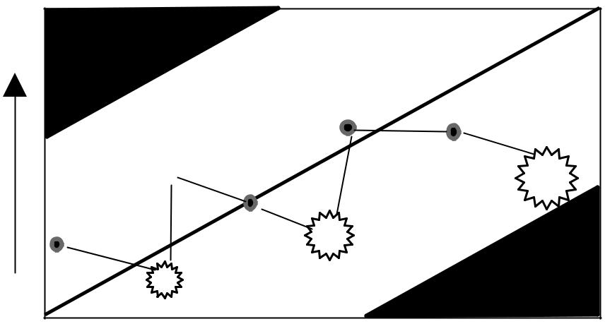
_{Protection} Bankruptcy

Unrocked

boat
Better defences

converted

to increased

production

Catastrophe


Production

Figure 28 The lifespan of a hypothetical organisation through the production - protection space. Reason, 1997

4.7 It is important that organisations balance profit and costs, and try to ensure that the defences which are put in place are the most cost-effective in terms of trapping errors and preventing catastrophic outcomes.

4.8 Ultimately, it is the responsibility of each and every aircraft maintenance engineer to take every possible care in his work and be vigilant for error (see Chapter 3, Section 1). On the whole, aircraft maintenance engineers are very conscious of the importance of their work and typically expend considerable effort to prevent injuries, prevent damage, and to keep the aircraft they work on safe.

Chapter 9 HAZARDS IN THE WORKPLACE

Hazards in the workplace tend to be a health and safety issue, relating to the protection of individuals at work. All workplaces have hazards and aircraft maintenance engineering is no exception. Health and safety is somewhat separate from human factors and this chapter therefore gives only a very brief overview of the issues relating the aircraft maintenance engineering.

- RECOGNISING AND AVOIDING HAZARDS

1.1 Potential Hazards in Aircraft Maintenance Engineering

1.1.1 There are may potential hazards in the aircraft maintenance industry and it is impossible to list them all here. However, a thorough health and safety appraisal will reveal the hazards. Physical hazards may include:

- very bright lights (e.g. from welding);

- very loud sounds (sudden or continuous);

- confined or enclosed areas;

- working at significant heights;

- noxious substances (liquids, fumes, etc.);

- excessive temperature (i.e. too cold or too hot);

- moving equipment, moving vehicles and vibration.

1.1.2 Many of these have been addressed earlier in this document (e.g. Chapter 5 “Physical Environment”).

1.2 Relevant Legislation and the Maintenance Organisation’s Responsibilities

1.2.1 The UK Health and Safety Executive (HSE) have responsibility for overseeing safety in the workplace. The Health and Safety at Work Act 1974 and accompanying Regulations are the relevant legislation and the HSE produce publications and leaflets summarising various aspects. The Health and Safety at Work Ac
policy with respect to the Health and Safety at Work of its employees. The employer is also obliged to bring to the notice of all its employees this policy together with the organisation and arrangements in force for carrying out that policy. Thus, in an aircraft maintenance organisation, the health and safety policy might include statements applicable to the organisation such as the need to:

Carry out assessments of work including inspections to determine Health and Safety risks;

- Provide safe working practices and procedures for plant, machinery, work equipment, materials and substances;

- Inform employees and other persons including temporary workers of any risk;

Provide for the welfare of employees;

- Discuss with and consult employee representatives on Health and Safety matters.

1.2.2 Maintenance organisations should appoint someone with health and safety responsibilities.

1.2.3 If hazards cannot be removed from the workplace, employees should be made aware that they exist and how to avoid them. This can be effected through training and warning signs. To be effective, warnings signs must:

- clearly identify the hazard(s);

- describe the danger (i.e. electric shock, radiation, etc);

- inform employees what to do or not to do.

1.2.4 The sign must attract an engineer’s attention, it must be visible and it must be understandable to the people it is aimed at. Additionally, in the maintenance industry, it must be durable enough to remain effective, often for years, in areas where dust and the elements can be present.

1.2.5 Positive recommendations are more effective than negative ones. For example, the statement "Stay behind yellow line on floor" is better than "Do not come near this equipment". Warning signs should contain a single word indicating the degree of risk associated with the hazard: DANGER denotes that the hazard is immediate and could cause grave, irreversible damage or injury. CAUTION indicates a hazard of lesser magnitude. The sign should also detail how to avoid or manage the risk. CAUTION signs are generally yellow and black. DANGER signs use red, black and white.

1.3 Engineer’s Individual Responsibilities

1.3.1 The legislation notes that every individual in a workplace also has health and safety responsibilities.

Every aircraft maintenance engineer should be aware that he can influence the safety of those with whom he works.

1.3.2 Thus, in an aircraft maintenance organisation, the health and safety policy might include statements applicable to engineers such as the need to:

- Take reasonable care of the health and safety of themselves and others who may be affected by their acts or omissions at work;

- Co-operate with the maintenance organisation to ensure that statutory requirements concerning health and safety at work are met;

- Work in accordance with any safety instruction and/or training received;

- Inform their supervisor or management of work situations that represent an immediate or potential danger to health and safety at work and any shortcomings in protection arrangements;

- Not interfere intentionally or recklessly with, nor misuse, anything provided in the interests of health and safety.

1.3.3 The attitude of an individual engineer, team or maintenance organisation (i.e. organisational culture) can have a significant impact on health and safety. Individuals who display an anti-authority attitude, are impulsive, or reckless are a danger in aircraft maintenance.

1.3.4 Safety In the Working Environment

Engineers should ensure that they keep the working environment safe. Clutter, rubbish, etc. is not only a nuisance to others, but can constitute a danger (e.g. a trip hazard, fire hazard, etc.). In addition, engineers should be careful when working on the line not to leave objects when a job has been completed. Foreign Object Damage (FOD) is a risk to aircraft operating at an airfield.

1.3.5 Safety When Working On Aircraft

Before operating or working on aircraft system, an engineer should carry out clearance checks around moveable surfaces (e.g. flying controls, landing gear, flaps, etc.). Deactivation procedures should be followed (e.g. pull circuit breakers, isolate valves, disconnect power, etc.). Notification of deactivation through the provision of adequate placard in key locations is essential to inform others of system status.

1.4 Dealing With Emergencies

1.4.1 Careful handling of health and safety in the maintenance environment should serve to minimise risks. However, should health and safety problems occur, all personnel should know as far as reasonably practical how to deal with emergency situations.

Emergencies may include:

- An injury to oneself or to a colleague;

- A situation that is inherently dangerous, which has the potential to cause injury (such as the escape of a noxious substance, or a fire).

1.4.2 Appropriate guidance and training should be provided by the maintenance organisation. The organisation should also provide procedures and facilities for dealing with emergency situations and these must be adequately communicated to all personnel. Maintenance organisations should appoint and train one or more first aiders.

The basic actions in an emergency are to:

- Stay calm and assess the situation

  - Observe what has happened;

  - Look for dangers to oneself and others;

  - Never put oneself at risk.

- Make the area safe

  - Protect any casualties from further danger;

  - Remove the danger if it is safe to do so (i.e. switching off an electrical current if an electrocution has occurred);

  - Be aware of ones own limitations (e.g. do not fight a fire unless it is practical to do so).

- Assess all casualties to the best of ones abilities (especially if one is a qualified first aider)

- Call for help

  - Summon help from those nearby if it is safe for them to become involved;

  - Call for local emergency equipment (e.g. fire extinguisher);

  - Call for emergency services (ambulance or fire brigade, etc.).

- Provide assistance as far as one feels competent to.

1.4.3 Emergency drills are of great value in potentially dangerous environments. Aircraft maintenance engineers should take part in these wherever possible. Knowledge of what to do in an emergency can save lives.

REFERENCE BOOKS

- Aviation Maintenance Technician Handbook - FAA-H-8083-30
- CAP 715
- CAP 716
- ICAO Document 9683

